SUBCOURSE EDITION
FA4230 A

U.S. ARMY FIELD ARTILLERY SCHOOL

CONDUCT A PRECISION
REGISTRATION WITH
ARTILLERY AND MORTAR

FIRE SUPPORT SPECIALIST
MOS 13F SKILL LEVEL 2

CONDUCT A PRECISION REGISTRATION WITH ARTILLERY AND MORTAR

SUBCOURSE FA4230

US Army Field Artillery School
Fort Sill, Oklahoma

4 CREDIT HOURS

This subcourse is designed to train the skills necessary for performing tasks related to selection, location, and precision registration. This subcourse is presented in three lessons corresponding to a terminal objective supporting the following soldier's manual tasks.

LESSON 1: Select and Locate Registration Points

TASK NO: 061-283-2101

TASK: Select and locate registration points.

CONDITIONS: You will be given a declinated M2 compass, binoculars, a coordinate scale, an observed fire (OF) fan, a map of the target area, and a zone of observation.

STANDARDS: Select and locate registration points close to the center of the target area or zone of action.

LESSON 2: Conduct an Impact and Time Registration

TASK NUMBER: 061-283-2102

TASK: Conduct an impact and time registration

CONDITIONS: You will be given a declinated M2 compass, binoculars, communications with the FDC, a designated registration point, a digital message device (DMD)(if so equipped), and a laser range finder (LR)(if so equipped).

STANDARDS: Follow precision registration without error.

W4898a

i

LESSON 3: Conduct a Mortar Precision Registration

TASK NO: 061-283-2104

TASK: Conduct a mortar precision registration.

CONDITIONS: You will be given a declinated M2 compass, binoculars, a map of the target area, communications with the FDC, a designated registration point, a digital message device (DMD)(if so equipped), and a laser range finder (LR)(if so equipped).

STANDARDS: Perform a mortar precision registration using mortar precision registration techniques without error.

ii

TABLE OF CONTENTS

Section Page

TITLE PAGE i
TABLE OF CONTENTS iii
ADMINISTRATIVE INSTRUCTIONS v
GRADING AND CERTIFICATION INSTRUCTIONS v
Lesson 1: Select and Locate Registration Points
Introduction 1
Selecting Reference Points 1
Selecting Registration Points 7
Locating the Registration Point 10
Summary 12
Lesson 2: Conduct an Impact and Time Registration
Introduction 13
Precision Fire 13
Initiating the Registration 13
Determining the Observer-Target Factor 14
Conducting the Precision Registration 15
Determining Refinement Data 24
Determining Range Refinement 24
Determining Deviation Refinement 30
Reporting Deviation and Range Refinement Data 32
Fuze Time Registration 34
Determining HOB Deviation Correction 37
Summary 39

iii

Section Page

Lesson 3: Conduct a Mortar Precision Registration
Introduction 41
Call for Fire 41
Target Location 43
OT Factor 43
Spottings 44
Deviation Spottings 45
Deviation Corrections 48
Range Corrections 49
Adjusting the Sheaf 51
Summary 54
EXAMINATION E-1

* * * IMPORTANT NOTICE * * *

THE PASSING SCORE FOR ALL ACCP MATERIAL IS NOW 70%

PLEASE DISREGARD ALL REFERENCES TO THE 75% REQUIREMENT.

iv

Lesson 1
SELECT AND LOCATE REGISTRATION POINTS

OBJECTIVE

Upon completion of this lesson, you will be able to select and locate registration points.

REFERENCES

This lesson is based on FM 6-30 and other materials approved for US Army field artillery instruction; however, development and progress render the text continually subject to change. Therefore, base your examination answers on material presented in this text rather than on individual or unit experience.

1. INTRODUCTION. There are many things a forward observer (FO) must know and be able to perform when he occupies an observation post (OP) and begins to select and locate a registration point. The FO must do a thorough job of terrain and map study when deciding his location. If his location is misplotted, all directions using the OF fan are incorrect. An experienced FO always has a good terrain sketch drawn up. This is an excellent tool to use in associating objects that are not shown on the map, but are physically located on the ground. Some of these objects can be used as reference points on your terrain sketch.

2. SELECTING REFERENCE POINTS. Reference points are easily identifiable points across the zone of observation from which you can quickly determine the direction to a target. Reference points can be hilltops, road junctions, church steeples, destroyed equipment, or any other feature that stands out.

1

a. The best way to keep track of reference points and the direction to them is to incorporate them into your terrain sketch. When occupying an OP, you must first make a sketch of the zone of observation. Starting with the skyline, sketch each prominent feature in your field of vision. Refer to the map in Figure 1. Assume you have occupied the OP indicated in grid square 9702, and your field of vision is the area outlined.

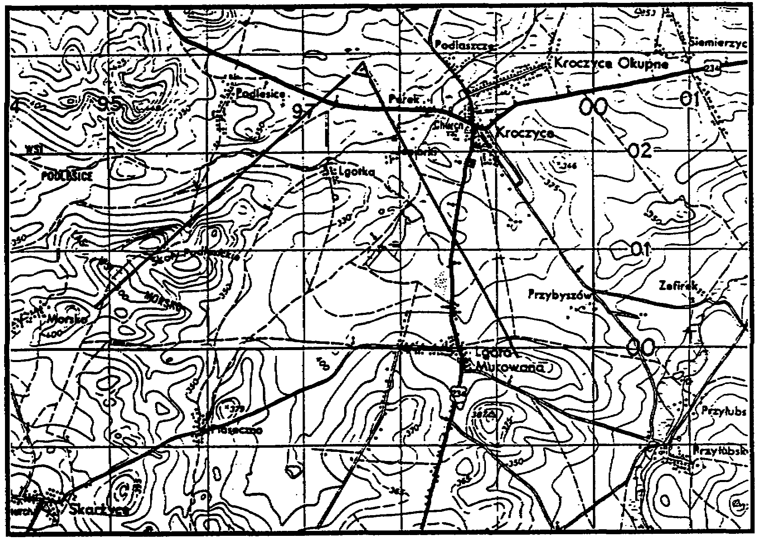

Figure 1.

2

A sketch of the skyline might look like the one in Figure 2 below.

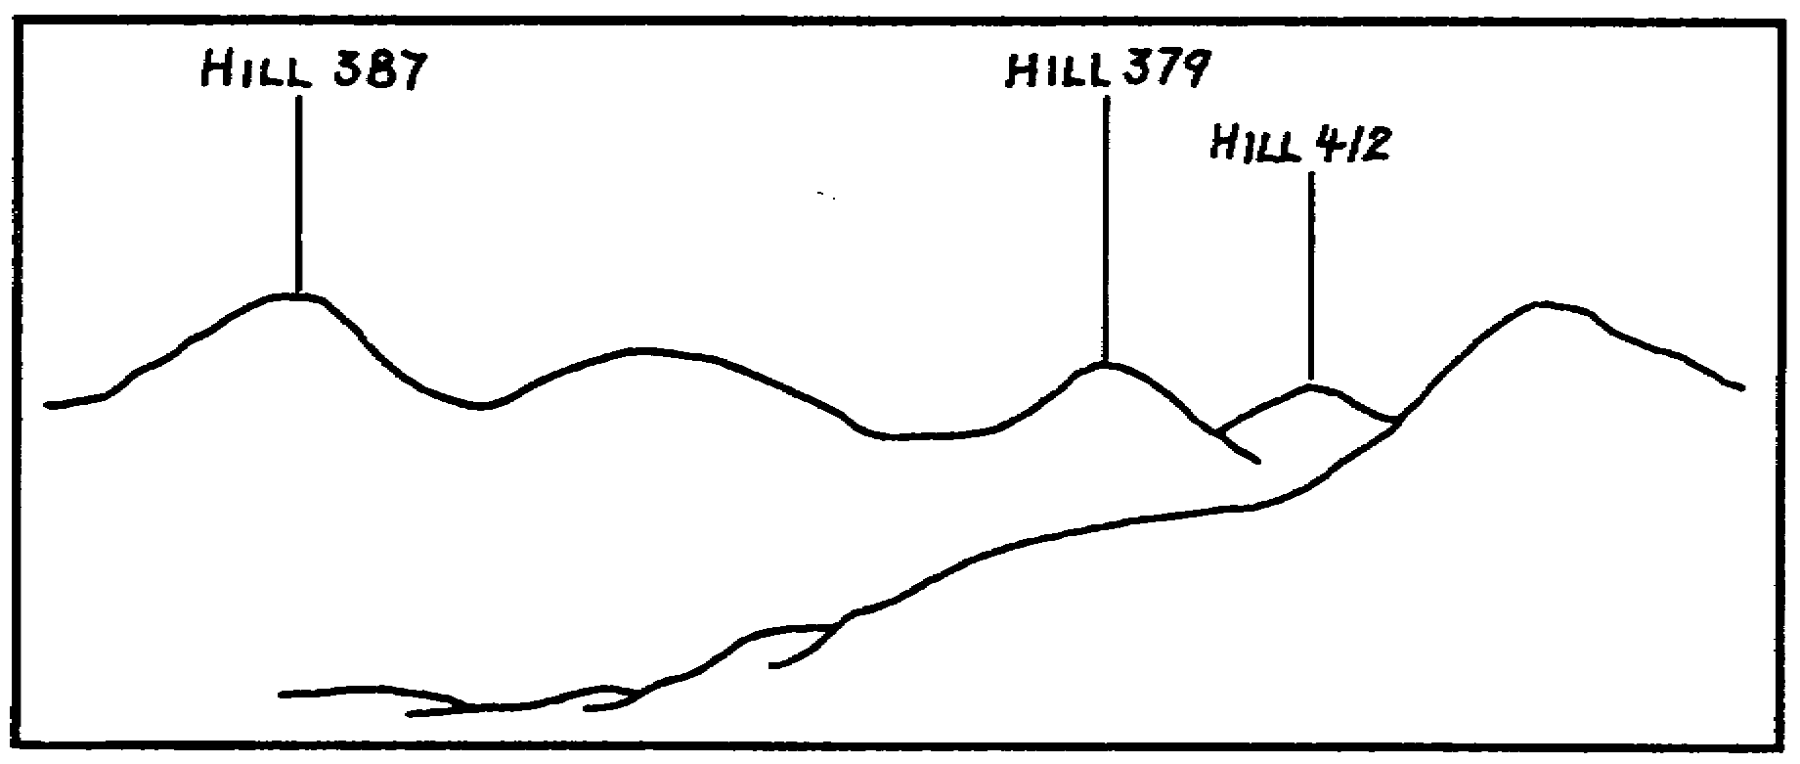

Figure 2.

Once you have sketched the skyline, sketch the prominent terrain features. You don't have to be an artist; a simple drawing will do. Your sketch might look like the one in Figure 3.

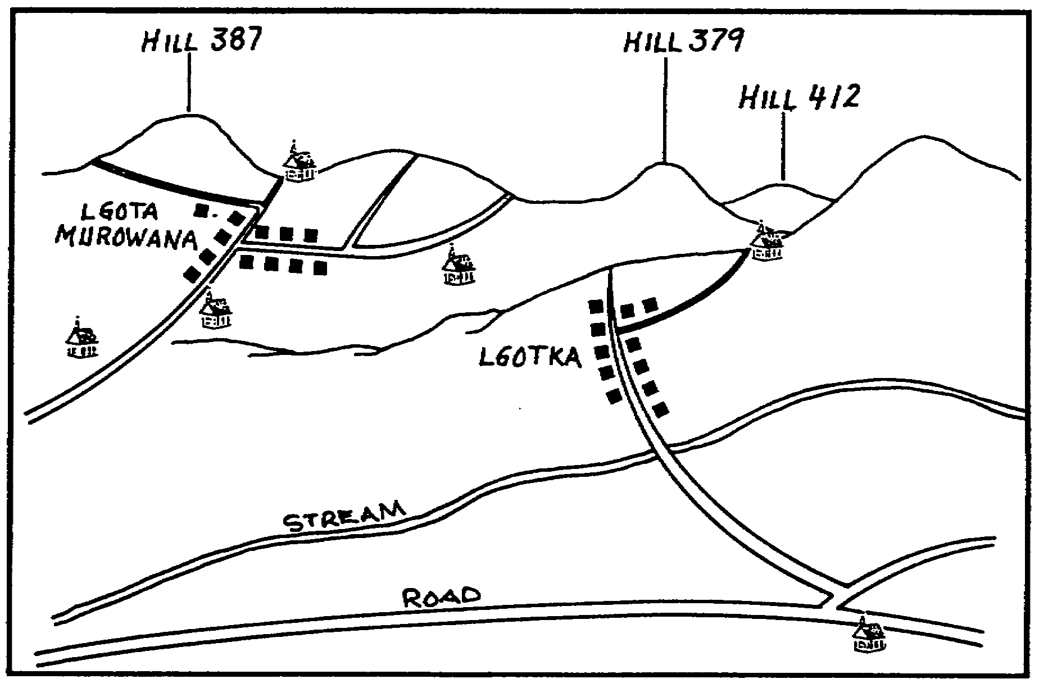

Figure 3.

3

b. Select several reference points you can identify easily. Since you will rarely attack targets at ranges that are very great, try to locate points that are close in and label them. There are a number of points you can use (as shown in Figure 4). You should have enough points to cover the zone of action.

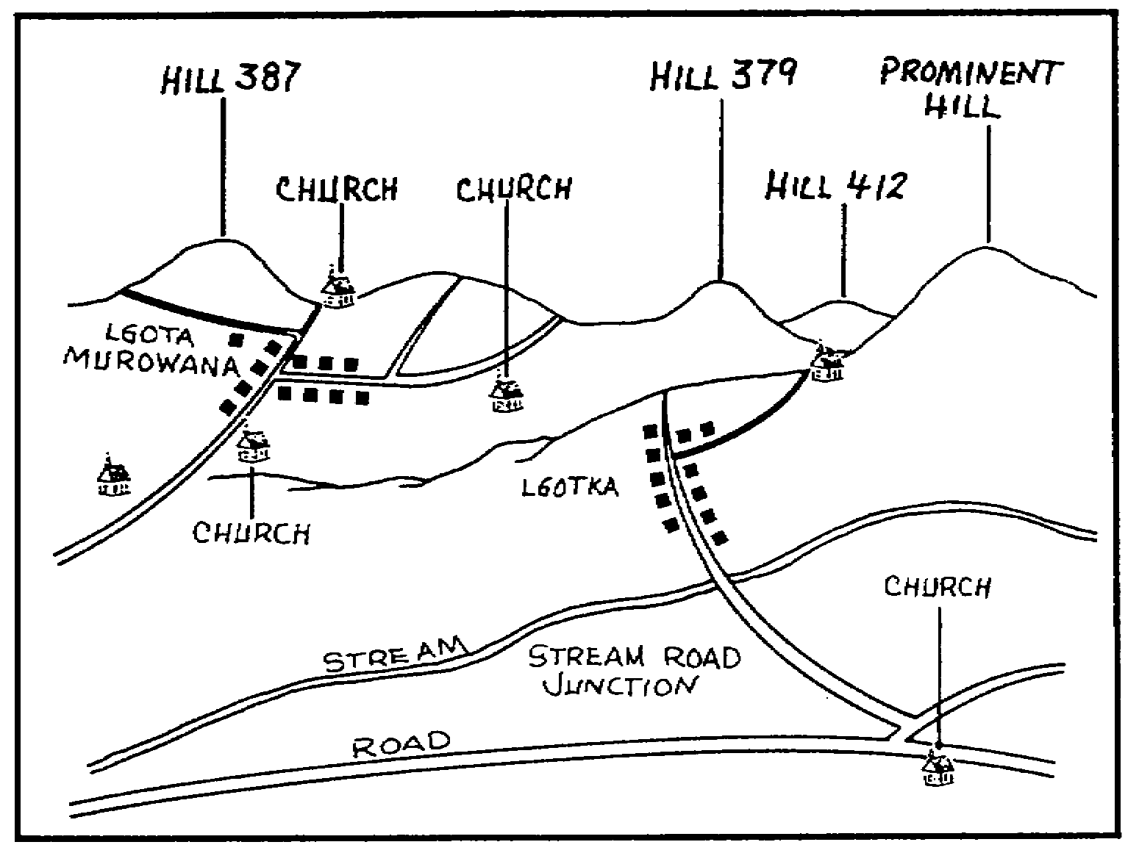

Figure 4.

c. Next, determine the direction to each of the reference points selected, and express it to the nearest 10 mils. Take your time and be as accurate as possible. The accuracy of these directions determines how accurate direction to a target is. You can determine the direction to reference points by using a declinated M2 compass or the OF fan. If the declinated M2 compass is used, be sure to--

• Hold the compass in a level position.

• Stay at least 10 meters from small metal objects (helmets and rifles).

• Stay away from large metal masses (vehicles and metal buildings).

• Stay away from generators and power lines.

4

If the OF fan is used--

• Tape or pin it to the map.

• Be sure it is properly oriented;

• Be sure the radial lines are properly labeled.

We used an OF fan set up like the one in Figure 5. We also circled our reference points to see them better in the illustration. You will be plotting targets on your map, so you do not need to mark your reference points.

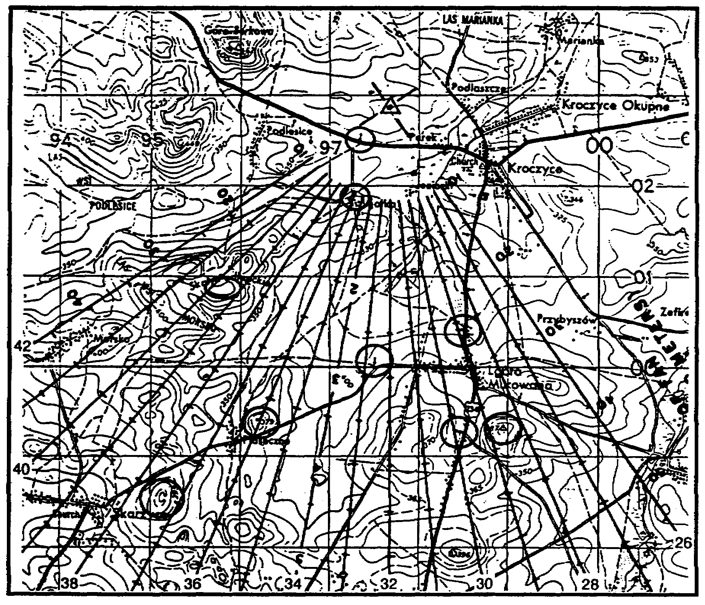

Figure 5.

5

d. Now, measure the direction to each of the reference points, and record the direction on your terrain sketch. You now have reference points to determine quickly the direction to any target you identify. Your sketch should look like the one in Figure 6.

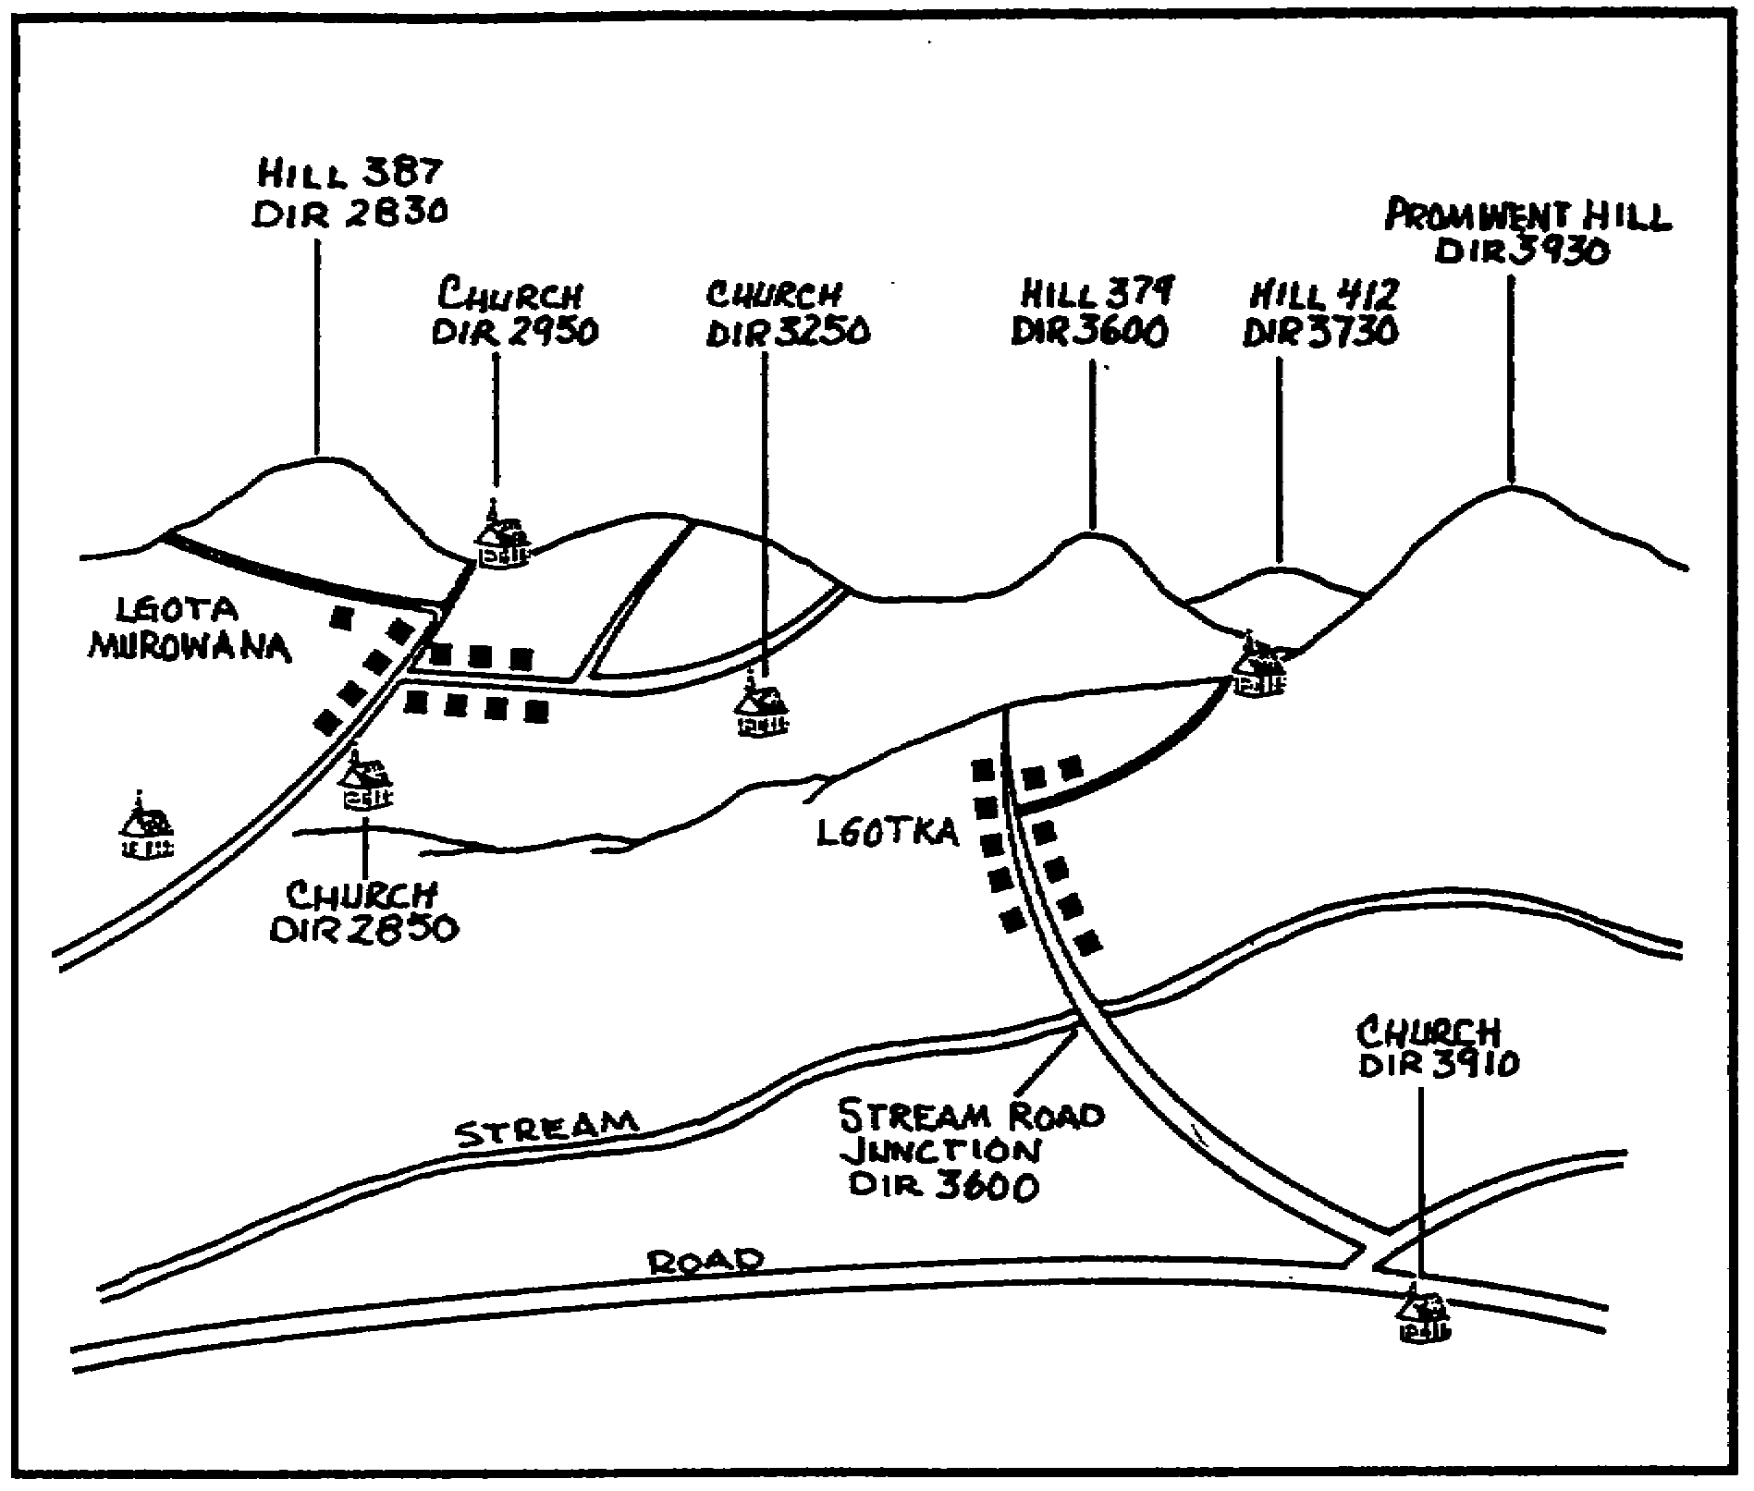

Figure 6.

6

e. You can increase the accuracy of your initial target location by making a table similar to Table 1. We recommend that it be covered with acetate and marked with a grease pencil. Then you can use it again.

Table 1.

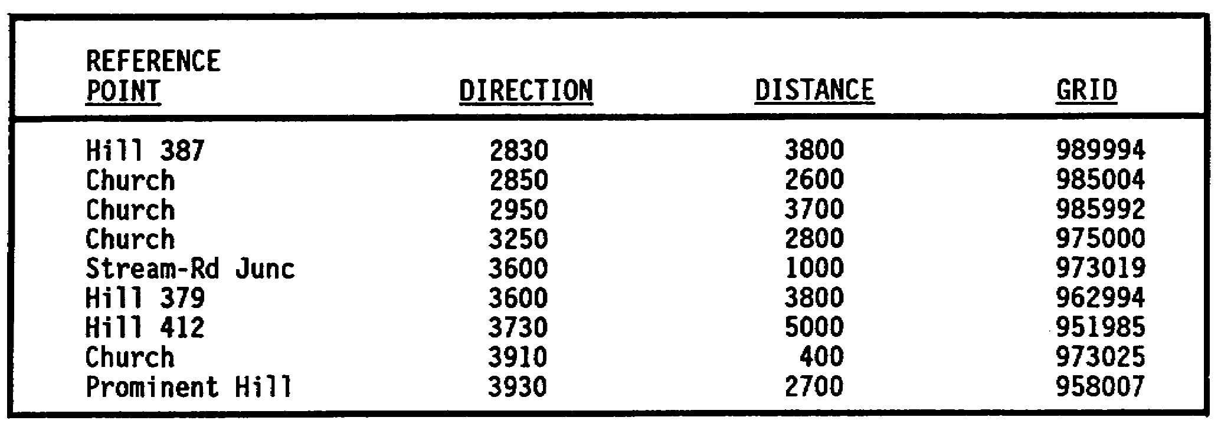

NOTE: For a more complete discussion of terrain sketches, see subcourse FA4215.

f. We said at the start of the lesson that a piece of destroyed equipment can be used as a reference point. A piece of destroyed equipment does have one drawback. Unless you can accurately determine the grid location of the equipment, the only thing it can be used for is determining direction to the target. A destroyed piece of equipment will not be shown on your map, so it is not the best aid in locating a target.

3. SELECTING REGISTRATION POINTS. When selecting registration points, the FO has to consider several things. Here are some features to look for when selecting points. A good registration point is--

• Easily identifiable, both on the terrain and on the map.

• Permanent or semipermanent.

• Near to the center of the zone of action.

• On flat or fairly level terrain.

• Not likely to be destroyed or displaced by a target hit.

• Short in height.

• Small in dimensions.

a. Location of registration point. You should try to locate all targets accurately, but a registration point must be located accurately. What this means is that you must be able to see it on the ground clearly and to associate

7

it to the map. This does not mean it has to be something shown on the map, but you should be able to associate it to the terrain features that are shown on the map.

b. Type of registration point. The registration point has to stay in place. In other words, it has to be permanent or semipermanent. A destroyed tank can work as a registration point, but be wary of selecting damaged equipment that might be moved.

(1) Try to find something near the center of your zone of action that increases the area of the zone that can be attacked by using registration corrections.

(2) Try to find something on fairly level terrain. A steep slope causes problems in the fire direction center (FDC) when the FDC personnel try to determine data from the registration. Also, you increase the probability of an error in the altitude of the point. Remember, the registration point must be easily identifiable on the map (including altitude).

(3) Select a registration point that can withstand a hit. If you pick a thatched roof hut for a registration point and you get a target hit, you are not going to have a thatched roof hut anymore. Therefore, you would not have a registration point either.

(4) Select a point with less than 5 meters in vertical height. A target on top of a tall structure gives the FDC false data (see Figure 7).

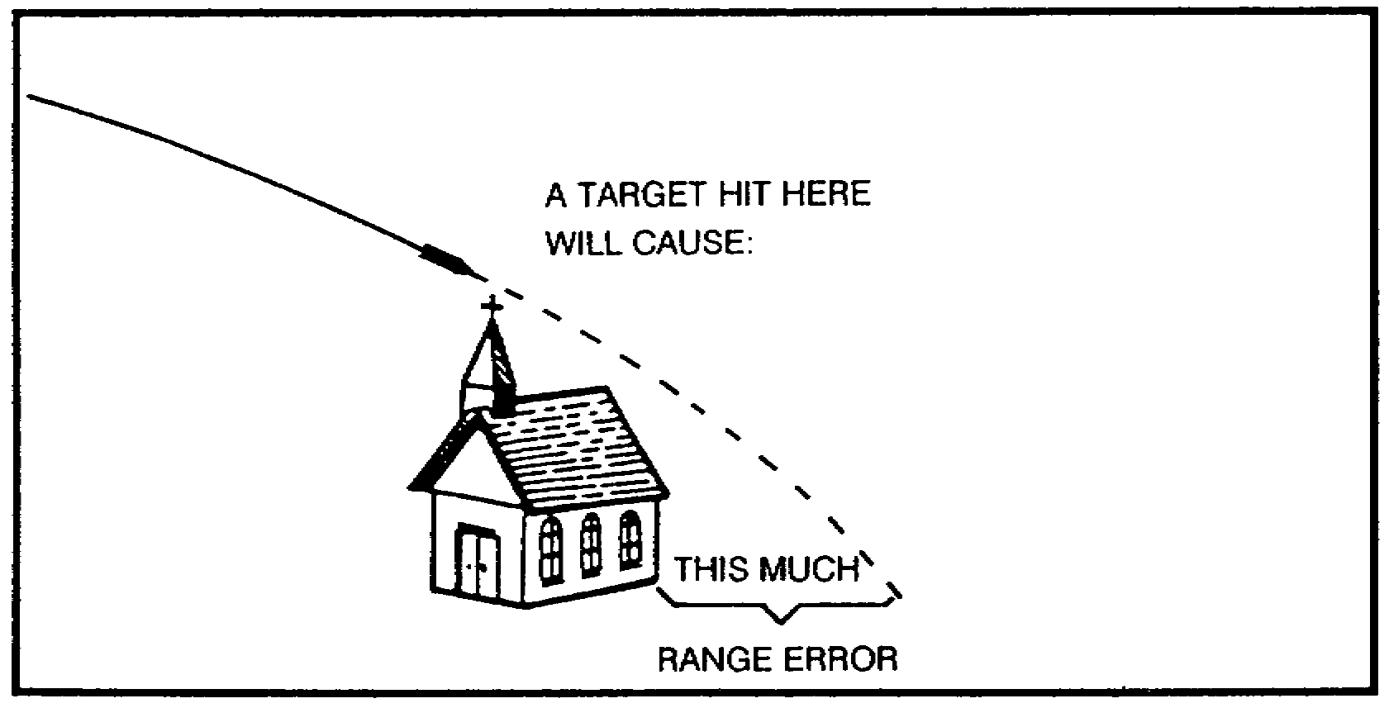

Figure 7.

(5) Select a target area about the size of a tank. A warehouse 100 meters long would be a poor choice for a registration point. You might get target hits all day, but they would not mean a thing.

8

PRACTICE EXERCISES:

Complete the following exercises by circling T for true or F for false, circling the letter preceding the correct answer, or filling in the blanks, as appropriate. Be sure to complete the practice exercises as they appear. They are "building blocks" and will help you complete the rest of the subcourse successfully. The answers follow the last exercise and are separated by rows of slashes (/////). If any of your answers are incorrect, restudy the appropriate part of the subcourse before you continue.

1. The registration point must be _____________ or _____________ .

2. The vertical height of a registration must be less than ____________ meters.

3. Study the figure below, and select the feature that you would use for a registration point.

(A) trees

(B) church

(C) road junction

(D) smoke

(E) lone tree

(F) bridge

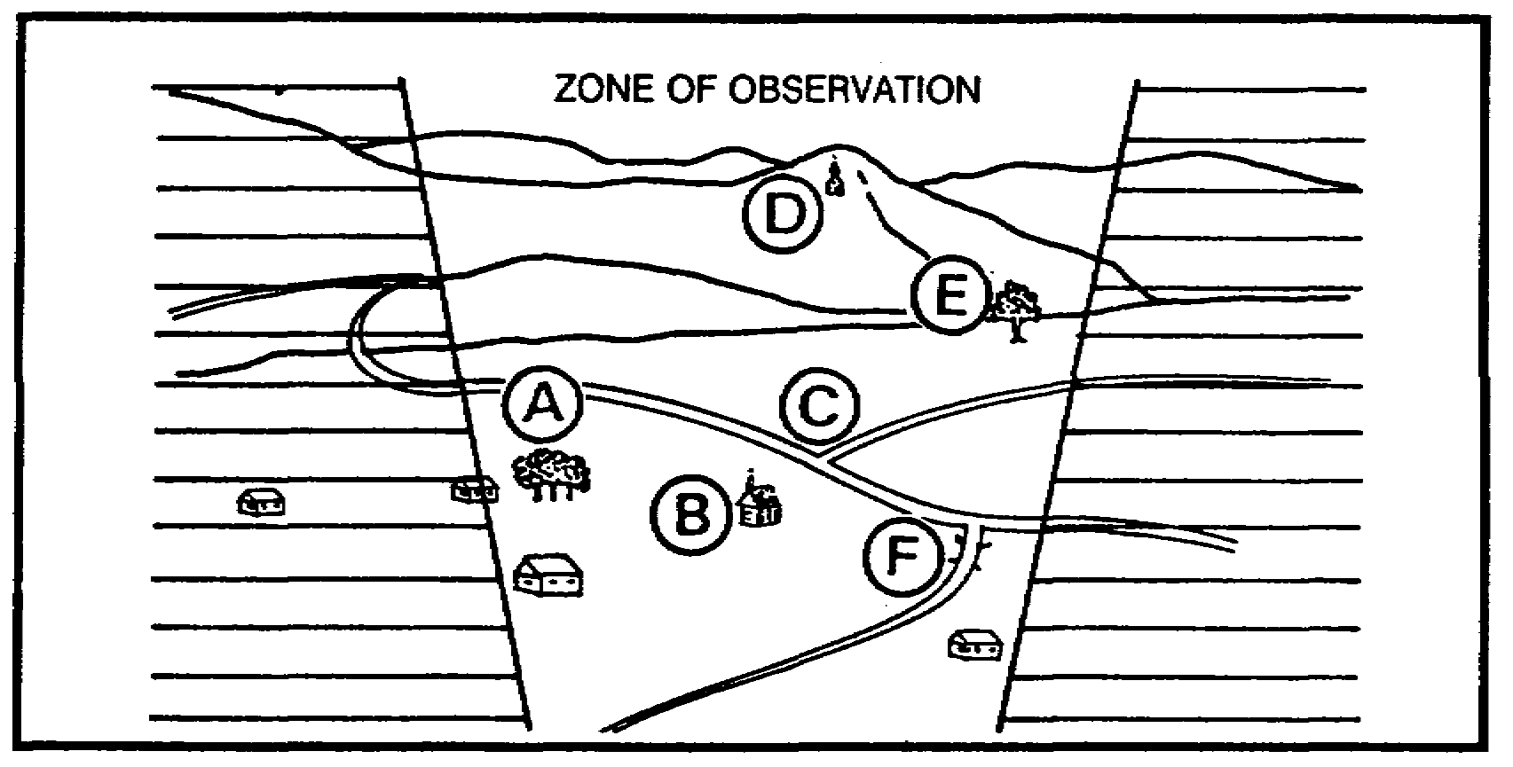

9

///////////////////////////////////////////////////////////////////////////////

ANSWERS:

1. permanent, semipermanent.
2. 5
3. (C)

///////////////////////////////////////////////////////////////////////////////

4. LOCATING THE REGISTRATION POINT. I said before that you must be very accurate when locating the registration point. You must determine the grid of the registration by eight-place coordinates (that is to the nearest 10 meters). The best way to get that kind of accuracy is to request the survey section to locate the registration point for you. That would be your first choice, and you should request it. However, survey teams are not normally available. This is why it is so important to have an easily identifiable point. By careful terrain analysis and map study, you should be able to locate the point by using eight-place coordinates. Finally, determine the direction to the registration point to the nearest 10 mils. Use the declinated M2 compass, and then check it with your OF fan. If they are close (±30 mils), use the direction determined with the compass. Remember I stated earlier that an-experienced observer would draw an accurate terrain sketch. Look at the terrain sketch and map in Figure 8. Make a careful examination of the sketch and map, and decide what to use for a registration point. Follow along with us, and see what we selected and why. We selected the road junction on the west side of Lgota Murowana, eight-place grid 97980002, direction 3070, and altitude 350 meters. Do not feel bad if you did not select the same point; there may be others. Ours is a compromise, and the registration points you pick in the real world will be too. You may not be able to find a point that completely fits the requirements that we have discussed. Let us discuss our choice and see if we agree.

10

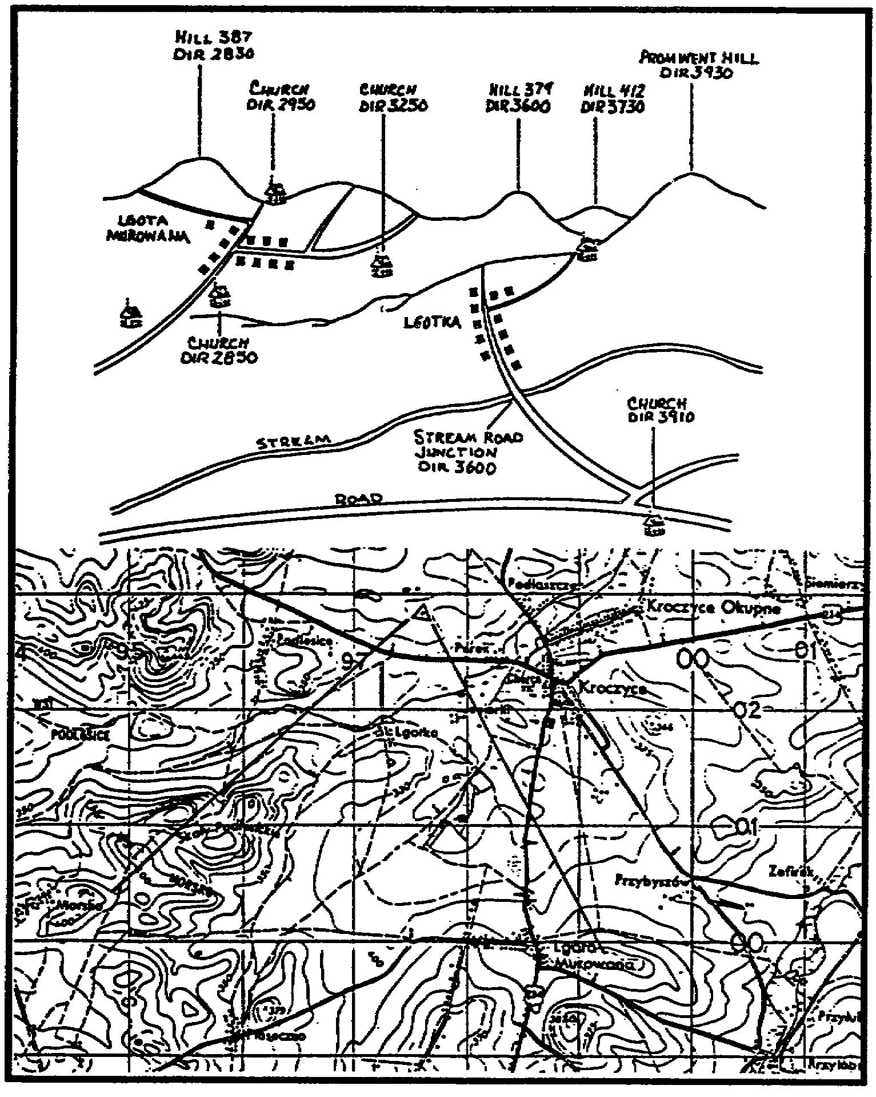

Figure 8.

• First, we said the point had to be easily identifiable on the ground and on the map. From the terrain sketch, it is easy to see we have a good view of the particular registration point. But one thing we liked best about our point was how accurately we could locate it on the map. Since it sits very close to a grid intersection, it was easy to get an accurate eight-place grid, and even better, the 350-meter contour line passes right through it.

11

• Next, we said it should be permanent or semipermanent, and our point is. Close to the center of zone of action? Well, as you can see, we did not do as well here as we would have liked. It is not dead center, but depending on what the range is from the battery to our point, registration corrections should be available for most of the zone of action. Notice, our point is on reasonably level terrain. The slope to the rear is not too steep. The point would not be destroyed by a target hit, and it has no vertical height, which could cause FDC errors.

• Finally, although our point is a little bigger than a tank, it is not so large that it can cause a problem by getting target hits over too large an area.

Now, look at the remaining reference points. We will explain why we did not select some of them for our registration point. Two groups we can eliminate are churches and hilltops. Church steeples have too much vertical height and can be destroyed by a target hit. Never select a hilltop for a registration point, because if a round goes behind the hill, you cannot make an accurate sensing. The stream-road junction might have been possible to use, but we felt it was a little too close for a registration point. If you were actually on the terrain, you might have found a sturdy, well-constructed, one-story building that was not too big to the west of Lgota Murowana. Not all reference points make good registration points, but all registration points make excellent reference points. Once the FDC has the grid of the registration point, you can locate targets by using the shift from a known point method of target location.

5. SUMMARY. In this lesson, we talked about reference points and registration points. We have learned that one of the first things an observer does when occupying an OP is to draw a terrain sketch. He then determines the direction to reference points and expresses it to the nearest 10 mils. When using the M2 compass, stay away from large masses of metal and stay at least 10 meters away from small metal objects (helmets and rifles). Finally, when selecting registration points, look for easily identifiable features on the map and on the terrain. Also, look for a registration point that is permanent, semipermanent, or not likely to be destroyed by a target hit.

12

Lesson 2
CONDUCT AN IMPACT AND TIME REGISTRATION

OBJECTIVE

Upon completion of this lesson, you will be able to conduct an impact and time registration.

REFERENCES

This lesson is based on FM 6-30 and other materials approved for US Army field artillery instruction; however, development and progress render the text continually subject to change. Therefore, base your examination answers on material presented in this text rather than on individual or unit experience.

6. INTRODUCTION. As an FO, you must master the Art of placing fire on a target. In so doing, you will be firing two types of missions--area fire and precision fire. Area fire procedures are discussed in subcourse FA4213. For the purpose of this lesson, we will be concerned only with precision fire.

7. PRECISION FIRE. The precision fire procedures place a great deal of responsibility on the observer. Precision fires are those fires that are directed against a point target such as a bunker, a road intersection, a disabled vehicle, or a building. There are two types of precision fire--precision registration and destruction. Both types are fired with a single piece. For the purpose of this lesson, we will discuss only precision registration. In a precision registration, enough rounds are fired on a point target, called a registration point, to determine corrections. These corrections compensate for nonstandard conditions and, when applied, improve the accuracy of the weapons.

8. INITIATING THE REGISTRATION. The precision registration is not initiated with the standard call for fire that you would use in an area type mission. In most cases, the fire direction officer (FDO) selects the registration point and gives it a number. He then passes this information to the observer, either in a face-to-face conference or by some type of radiotelephone communication. When the observer has occupied his post, he locates the registration point on the ground and measures the azimuth to its location. The registration point should be accurately located, semipermanent, near the center of the zone of action, and on fairly level terrain if possible. Here is how the registration works when initiated by the FDC as a message to observer (MTO).

• (FDC) H18 THIS IS H44, REGISTER ON KNOWN POINT 2, QUICK AND TIME1, OVER. (Read back by observer.)

• (Observer) DIRECTION 6400, OVER2. (Read back by FDC.)

• (FDC) SHOT, OVER. (Read back by observer.)

1 The announcement of QUICK AND TIME alerts the observer that impact and time portions will be conducted.

2 The observer's response to the MTO indicates that he is ready to observe.

13

I stated earlier that the FDO normally selects the registration point. However, the occasion could arise when the observer is called to select the registration point. In this case, the registration is initiated by the FDO with an MTO as follows:

(FDC) H18 THIS IS H44, SELECT REGISTRATION POINT VICINITY GRID 6138, QUICK AND TIME, OVER. (Read back by observer.)

The observer searches the terrain in grid square 6138 until he finds a suitable object on which to register. The target must be a permanent or semipermanent object. After he finds a point, he refers to his map and determines the grid coordinates to 10-meter accuracy (eight-place digits). Next, he determines the direction to the registration point. Once he has determined the grid and direction, he transmits the data to the FDC as shown below:

GRID 61543813, DIRECTION 4820, OVER.

The FDC and the observer are now ready to fire the precision registration.

PRACTICE EXERCISES:

4. T F The FDO will always select the registration point.

5. T F The grid coordinates of a registration point are determined to a 100-meter accuracy.

6. T F The precision registration is always conducted with one gun.

///////////////////////////////////////////////////////////////////////////////

ANSWERS:

4. F

5. F

6. T
///////////////////////////////////////////////////////////////////////////////

9. DETERMINING THE OBSERVER-TARGET FACTOR. As soon as you have determined the observer-target (OT) direction and transmitted It to the FDC, the next step is to determine the OT factor. The OT factor, or observer-to-target factor, is a value used to convert observer deviation spottings, measured in mils, to deviation corrections in meters. Before you can determine an OT factor, you must first determine the distance, in meters, from your observer location to the target or adjusting point. You can measure the distance from a map, or you can estimate it. Only experience and knowledge of the terrain can help you to estimate accurate OT distances. When the OT distance is-greater than 1,000 meters, first round that distance off to the nearest thousand meters, then divide the rounded-off distance by 1,000. We call this rounding off procedure "expressing" the distance. This gives you the OT factor. When the distance is less than 1,000 meters, we use basically the same procedure except that the distance is expressed

14

to the nearest hundred meters and is stated as a decimal. Make sure you understand how to determine the OT factor, because it will be used to compute your deviation corrections throughout the lesson. Table 2 shows some examples on determining the OT factor.

Table 2.

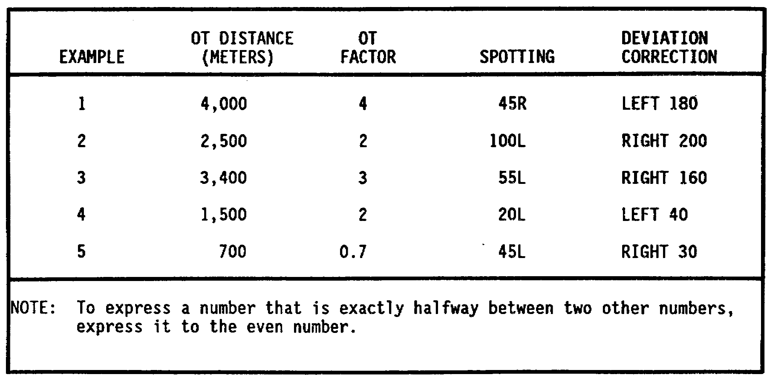

10. CONDUCTING THE PRECISION REGISTRATION. The bracketing procedure is used in both area fire and precision fire. In area fire, the bracket size is reduced until you split a 100-meter bracket or spot a range correct. In a precision registration, the bracket size is reduced until you split a 50-meter bracket, spot a range correct, or spot a target hit. But as I stated before, in this lesson, we are conducting precision fire.

15

a. When you are conducting a precision registration, it is very important that you keep track of where each round impacted with respect to the registration point (reg pt). This becomes critical as you reach the end of the mission. Until you gain confidence in yourself as a "very good forward observer," we suggest that you sketch a reticle pattern on a sheet of paper as we have in Figure 9. As each round appears, enter it on the paper, showing its relative location to the OT line and the registration point. The circled one (1)), for example, represents round one. Once you have made the round identification, enter the spotting and the correction. For round one, we spot over, 20 right (+, 20R). We determine that our OT factor (the distance from the observer to the target in thousands of meters) is two. Multiply the OT factor by the spotting to get the correction. You would send the FDC a correction of left 40, drop 200 (L40, -200). Study Figure 9 until you have memorized this procedure.

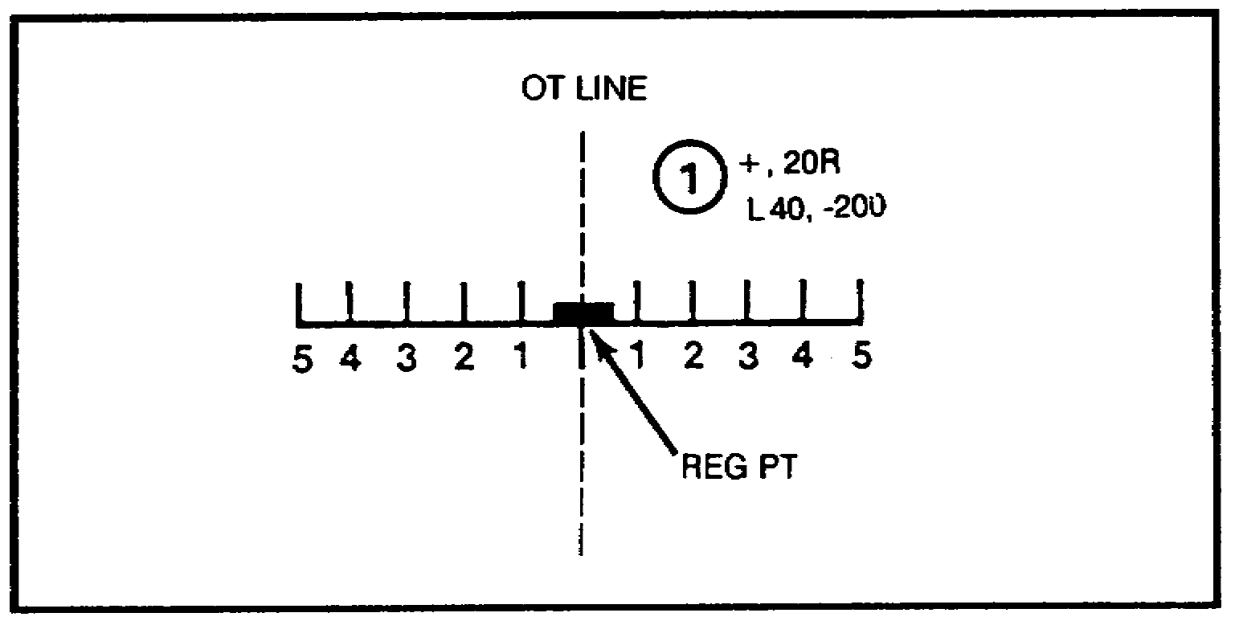

Figure 9.

b. In a precision registration, the rounds are spotted to the nearest 1 mil and corrected to the OT line before splitting the 200-meter bracket. Also keep in mind that the corrections are made to the nearest 10 meters. When the 200-meter bracket has been established, you do not make further corrections for deviation. Deviation for subsequent rounds is noted on your reticle pattern sketch for later reference. Let us "walk" through one together and see how the entries are made on the sketch. In Figure 10, we show round 1 as it appears in the binoculars and its entry on the sketch. Our spotting is over, and we determine that it is over by about 350 meters. We also can see that it is 25 mils left of our reg pt. Using an OT factor of two, we send a correction of right 50, drop 400 to the FDC. We entered both the spotting over, 25 left and the correction right 50, drop 400. We correct deviation until we establish the 200-meter bracket. After a few seconds, we hear this transmission from the FDC: SHOT, ROUND 2, OVER. The round as viewed in the binoculars is shown in Figure 11. We have also made our entries in Figure 11 showing round 2. We spot round 2 as short, 5 right (-, 5R) and have a correction of add 200 (+200). We have the 200-meter bracket, so note the deviation and correct the range only. Once you have made the proper entries on the sketch, send the corrections to the FDC.

16

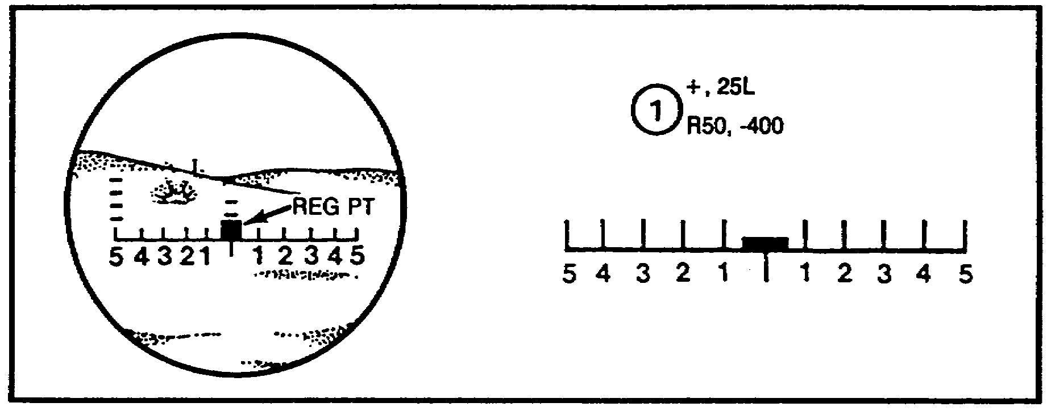

Figure 10.

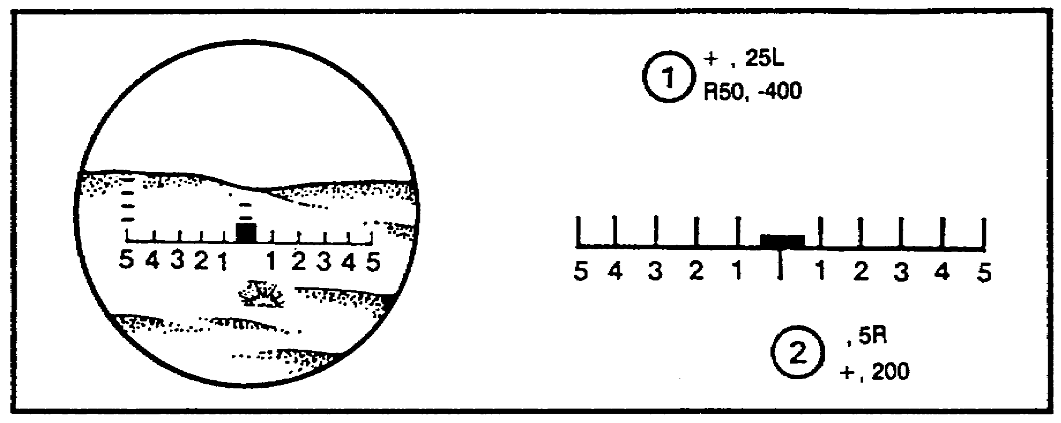

Figure 11.

In a few seconds time, the FDC will announce SHOT, ROUND 3, OVER. The registration continues like this until--

• You split a 50-meter bracket or

• You spot a range correct or

• You spot a target hit.

NOTE: A spotting of range correct or target is counted as both an over and a short.

When the 50-meter bracket is established, the method of fire is changed to two rounds. These two rounds should appear in the opposite sense to the round that established the 50-meter bracket (short to over or over to short). If both

17

rounds are in the opposite sense, the method of fire is changed to one round, and it is fired to verify and check the opposite end of the bracket. The rounds keep coming until one of two conditions occur:

• You spot two overs and two shorts along the OT line fired with data 25 meters apart, or

• You spot two overs and two shorts along the OT line fired with the same data.

c. Let us go through a complete impact registration together. We will illustrate the rounds as they appear in the target area. Get a blank sheet of paper, and make a reticle sketch large enough to take care of many rounds. As each round is shown, enter its number, your spotting, and the correction that you would send to the FDC. When you are ready, make your entries for the rounds shown below.

(1) The FDC says SHOT, OVER. You read back SHOT, OUT. This is round one (Figure 12). For range, the round appears to be about 300 meters short. The OT factor is two. Mark the round on your sketch, and send the corrections to the FDC.

(2) SHOT, OVER. This is round two (Figure 13). Enter this round on your sketch, and send the corrections to the FDC.

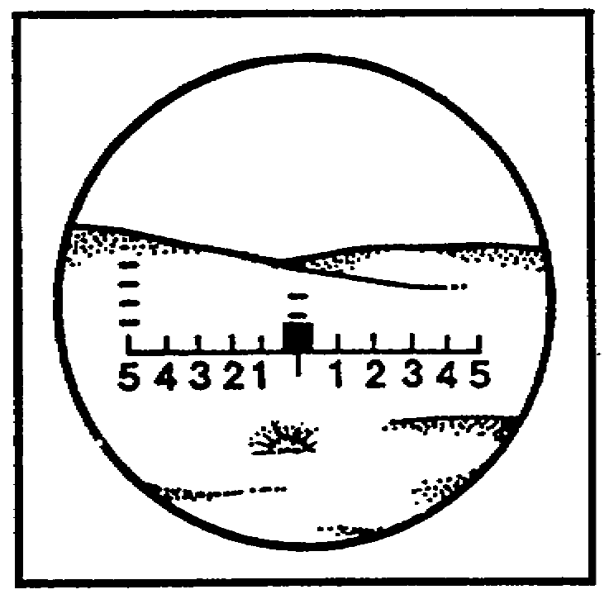

Figure 12.

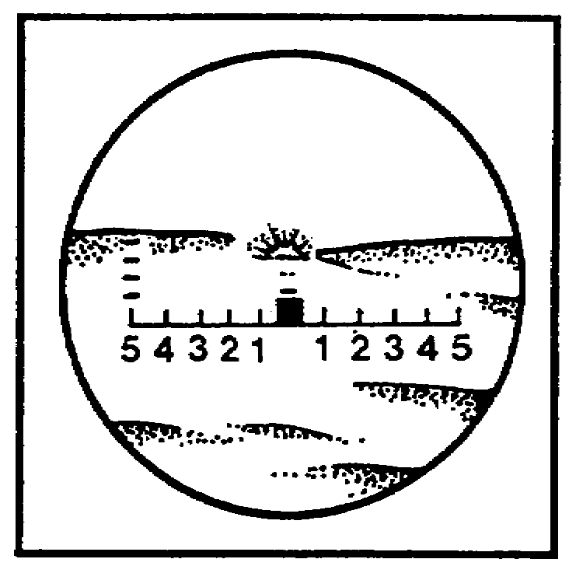

Figure 13.

18

(3) SHOT, OVER. This is round three (Figure 14). Enter this round on your sketch, and send the correction to the FDC.

(4) SHOT, OVER. This is round four (Figure 15). Enter this round on your sketch, and send the corrections to the FDC.

(5) SHOT, OVER. If you are on track, you should see that round five has established a 50-meter bracket (Figure 16). Remember, when we establish the 50-meter bracket, we call for two rounds that should appear in the opposite sense. In this case, we transmit: TWO ROUNDS, ADD 25, OVER.

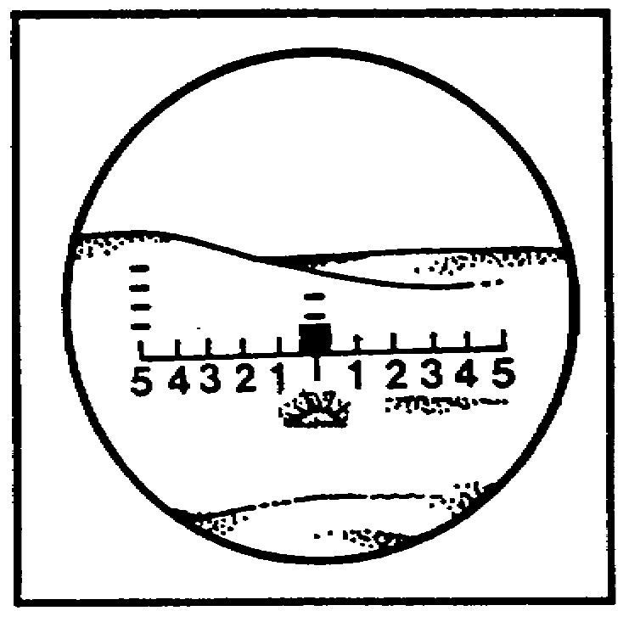

Figure 14.

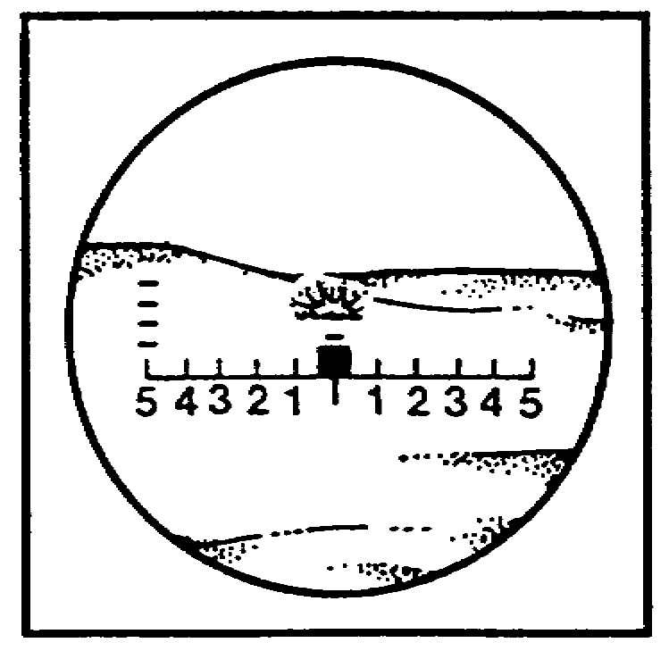

Figure 15.

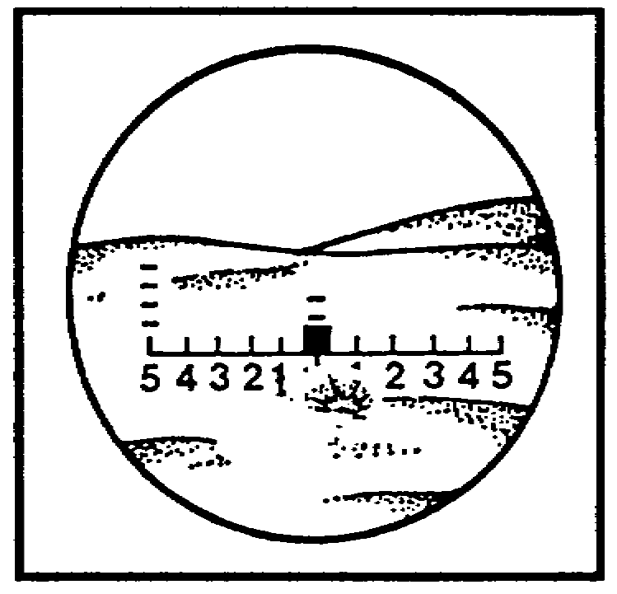

Figure 16.

19

(6) SHOT, OVER.---ROUNDS COMPLETE, OVER. Round six is to the left of round seven (Figure 17). We now have two rounds over (six and seven) and one round short (five). We change our method of fire and fire one round to verify and check the opposite end of the bracket. Transmit: 1 ROUND, DROP 25, OVER.

(7) SHOT, OVER. Put round eight on your sketch. This round completes this mission as far as fuze quick is concerned. If you were going to fire the time fuze, you would continue. (See Figure 18.)

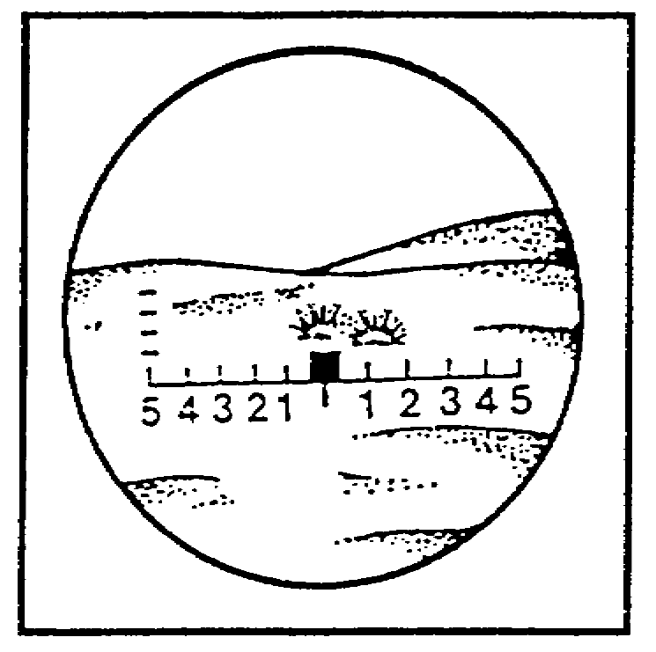

Figure 17.

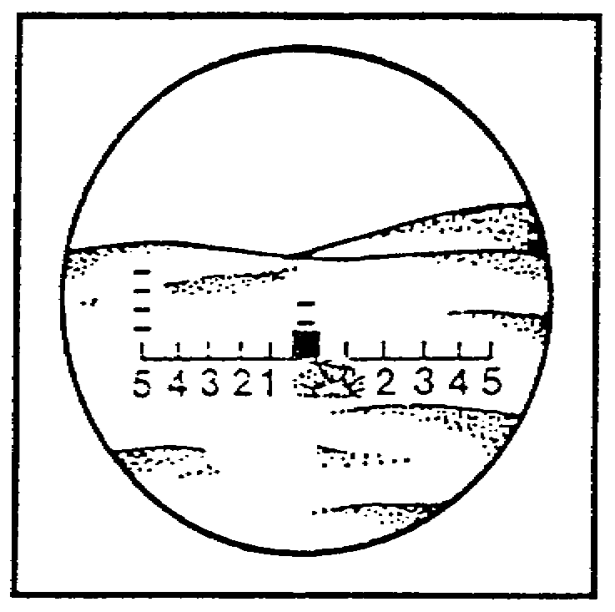

Figure 18.

20

d. Our sketch is as shown in Figure 19. Does yours look similar? Check our explanations for each round on the following pages. If you are having problems, you need to review before proceeding with the lesson.

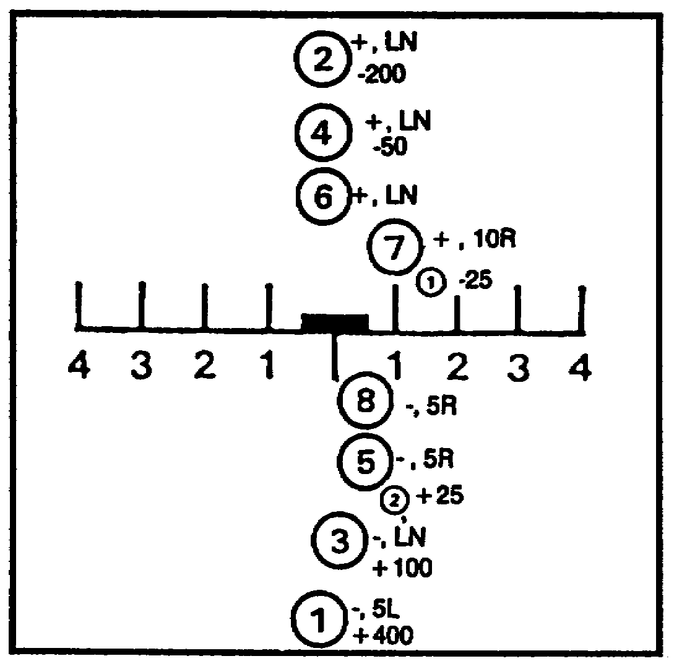

Figure 19.

Follow along as we explain. We began by sketching the reticle near the center of a whole sheet of paper. We then entered each round on the sketch, showing its location relative to the OT line and the registration point. Along with the round location, we entered the spotting and the correction. As we explain a round or rounds, we will give you the page number on which the rounds are shown as seen through the binoculars. Refer to these figures if you want to, and reread the information pertaining to the figure.

• Round one (page 18). We spotted this round short by about 300 meters and about 5 mils to the left of the OT line (see Figure 20). For simplicity, we show the spotting as -5L. Since the round was about 300 meters short, we send a correction to the FDC of add 400 (+400) to establish a bracket.

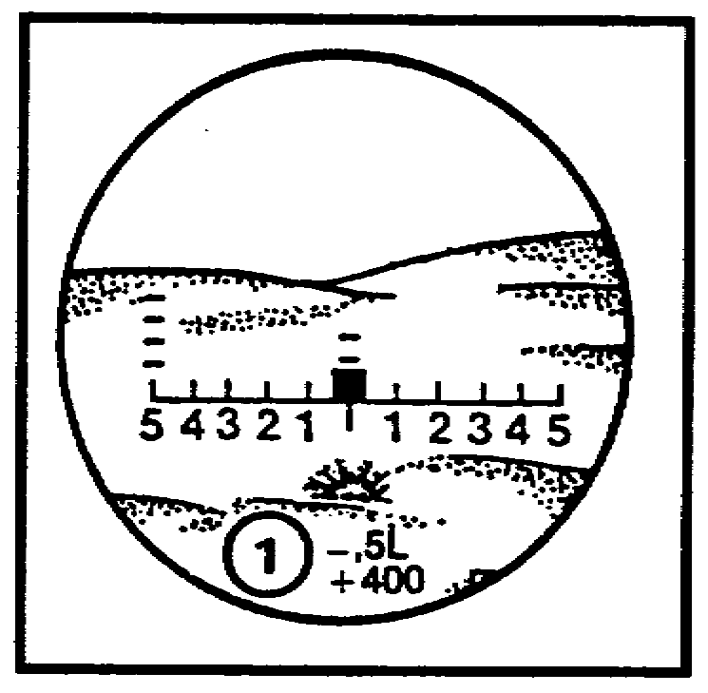

Figure 20.

21

• Round two (page 18). We spot round two as over, line (this round established a 400-meter bracket) and correct with a drop 200 (see Figure 21). The entries on the sketch are +LN for the spotting and -200 for the correction.

• Round three (page 19). We spot round three as short, line (this round established the 200-meter bracket) and correct with an add 100 (see Figure 22). The entries on the sketch are -LN for the spotting and +100 for the correction.

• Round four (page 19). We spot round four as over, line (this round established the 100-meter bracket) and correct with a drop 50 (see Figure 23). The entries on the sketch are +LN for the spotting and -50 for the correction.

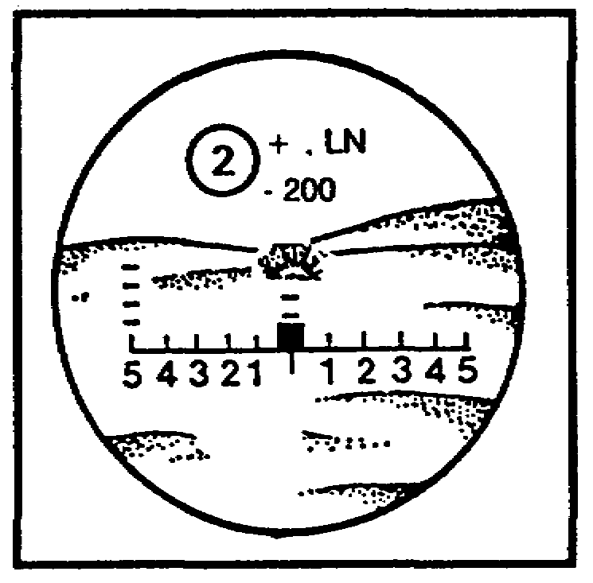

Figure 21.

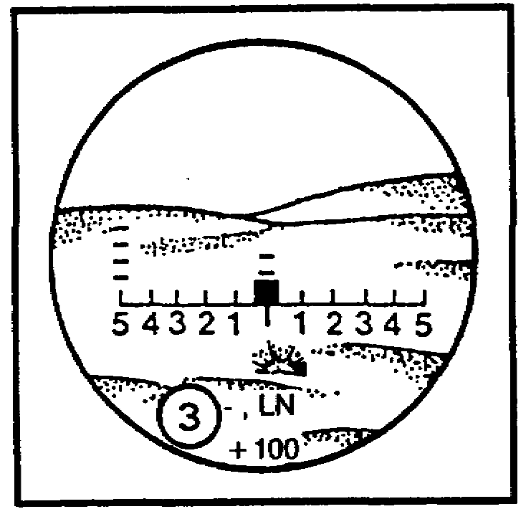

Figure 22.

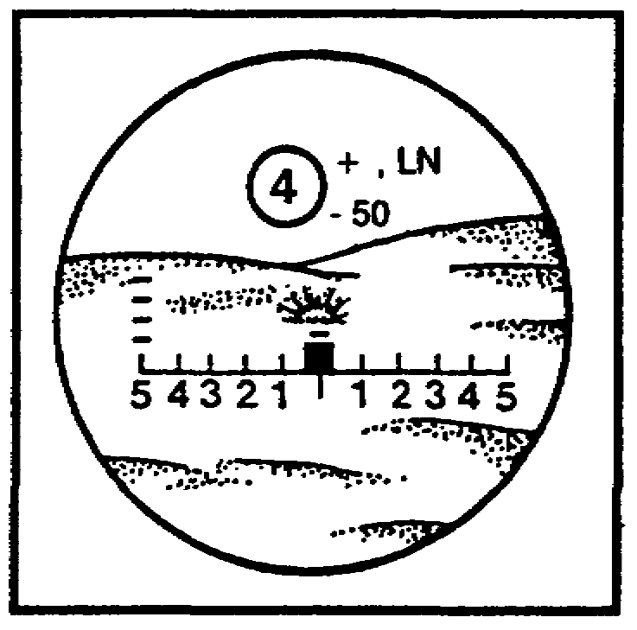

Figure 23.

22

• Round five (page 19). We spot round five as short, 5 right and correct with two rounds, add 25 ((2) +25) (see Figure 24). When you-have established one end of a 25-meter bracket, change the method of fire to two rounds and check the other end of the bracket. Recall that we are looking for two overs and two shorts fired with data 25 meters apart or with the same data.

• Rounds six and seven (page 20). We asked for two rounds, so we spotted each and made one correction. Round six we spotted as over line, and round seven we spotted as over, 10 right. Our correction is one round, drop 25 ((1) -25). We changed the method of fire to one round so that we can check and verify the opposite end of the bracket. (See Figure 25.)

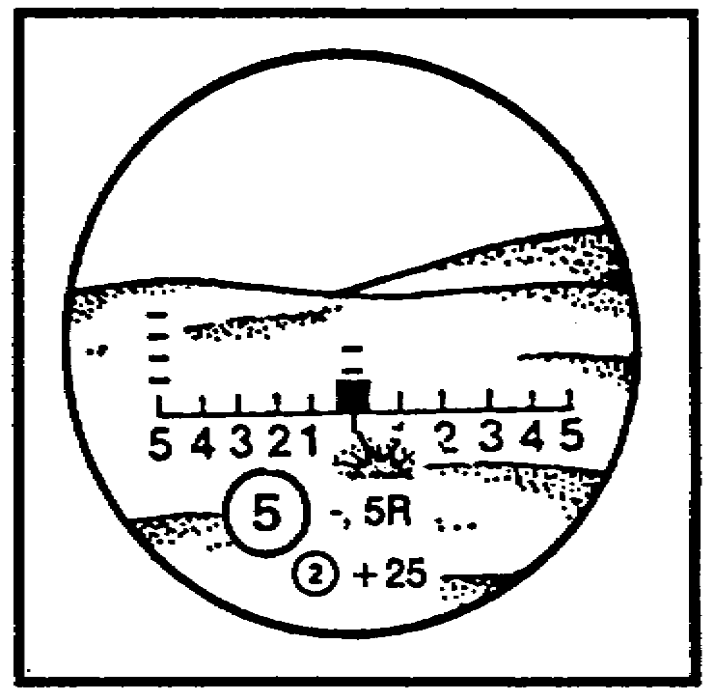

Figure 24.

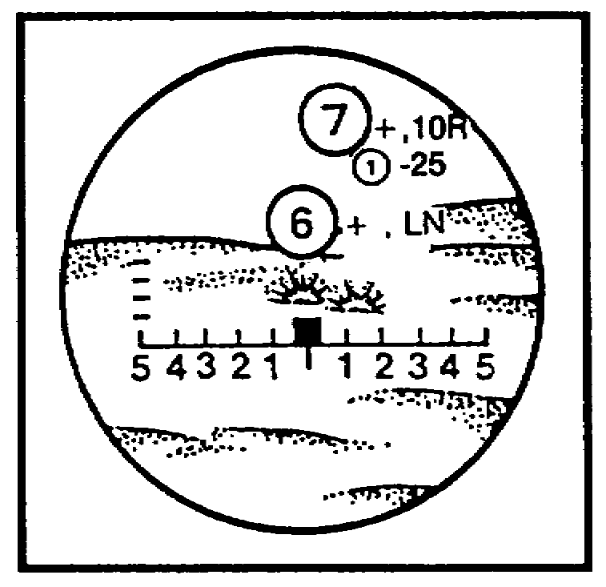

Figure 25.

• Round eight (page 20). We spot round eight as short line, 5 right. Round eight is the last round fired in the fuze quick registration. The next step is refinement data, which is covered in the following paragraph. Be sure you understand spotting and corrections before you continue this lesson.

PRACTICE EXERCISES:

7. Deviation is corrected until a __________________ bracket is established.

8. A spotting of range correct or target is counted as both an _____________
and a _____________ .

23

///////////////////////////////////////////////////////////////////////////////

ANSWERS:

7. 200-meter
8. over, short.

///////////////////////////////////////////////////////////////////////////////

11. DETERMINING REFINEMENT DATA. I mentioned earlier that the objective of the registration was to obtain spottings of two overs and two shorts along the OT line from rounds fired with the same data or from rounds fired with data 25 meters apart. In the mission that we just fired, rounds five, six, seven, and eight achieved this goal. Round five was short, rounds six and seven were over, and round eight was short. To achieve spottings of two overs and two shorts normally requires four separate rounds to be fired; however, a target hit or a range correct can provide spottings of both over and short. Thus, the objective could be achieved with two consecutive target hits or range correct spottings. It could also be achieved with one short (or over) round, a target hit or range correct, and another round over (or short). When the requirement of two overs and two shorts with the same data or data fired 25 meters apart has been met, the impact registration with the quick fuze is ended and refinement data are determined. Refinement data may include either a range correction or a lateral correction, or both, to the nearest 10 meters.

12. DETERMINING RANGE REFINEMENT. Before we can determine range refinement data, we must know where the registration point is in relation to the two sets of spottings (overs and shorts). There are three rules that help us determine our range refinement. Study these rules, and become familiar with them.

• If the registration point is nearer the spotting(s) of the last round(s) fired, no range refinement is necessary (see Figure 26).

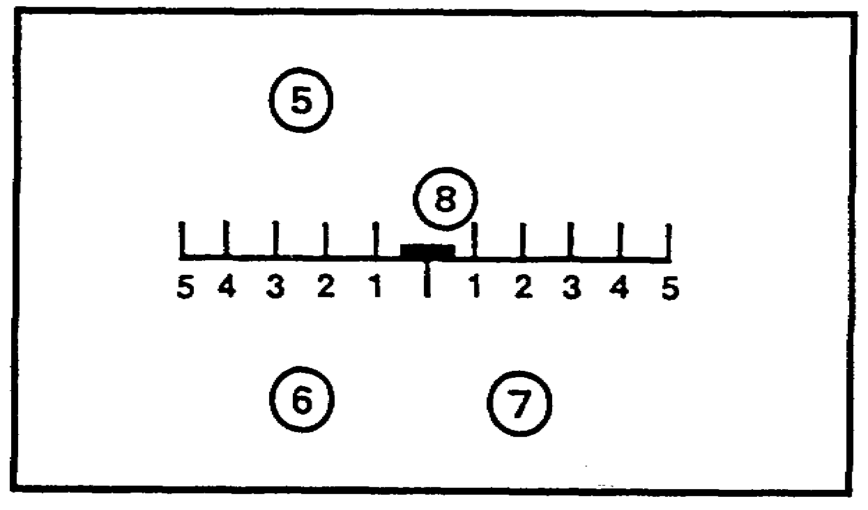

Figure 26.

24

• If the registration point is equidistant between two sets of bursts, you determine the range refinement to be an add or drop 10 from the last round fired (see Figure 27).

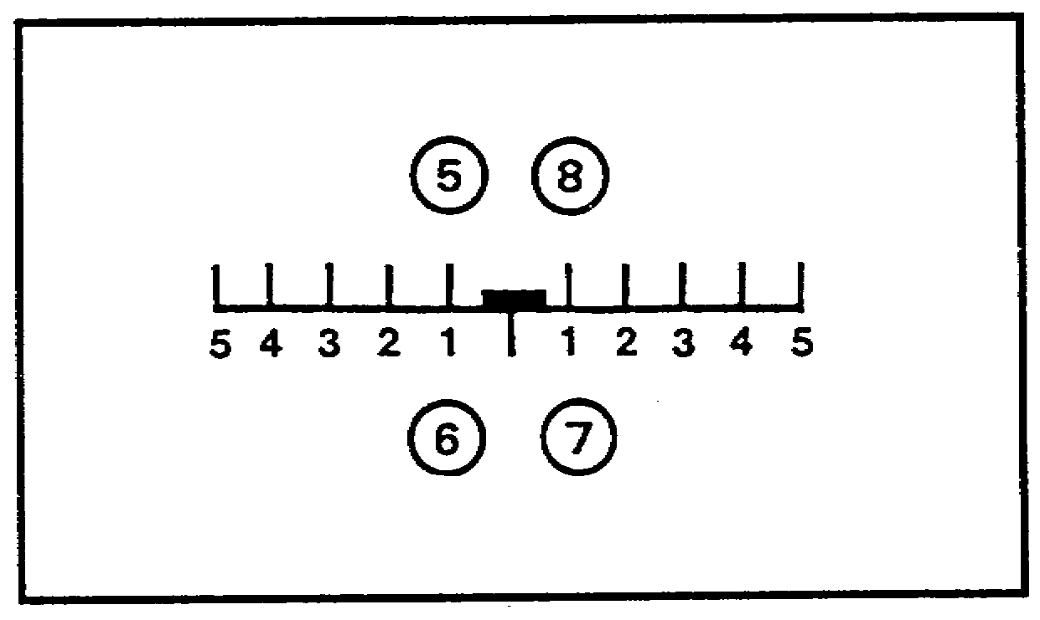

Figure 27.

• If the registration point is farther from the last round(s) fired, you determine the range refinement to be an add or drop 20 (see Figure 28).

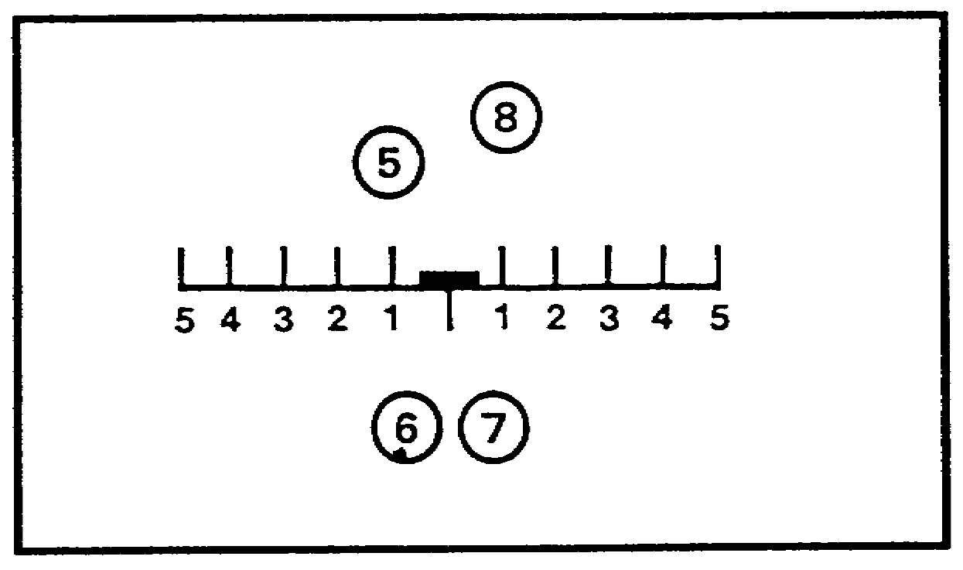

Figure 28.

25

a. The mission that we fired earlier is going to be used to determine our range refinement data. Rounds five, six, seven, and eight will be used because they gave us our two overs and two shorts 25 meters apart. Figure 29 shows what these rounds looked like.

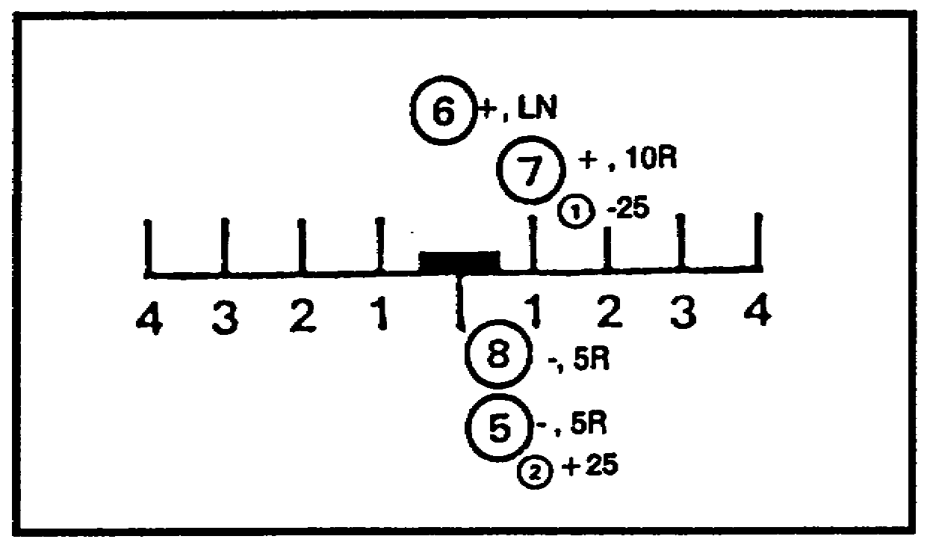

Figure 29.

Now if we refer back to our rules for range refinement data, we can determine what our range refinement is. In this case, round eight (our last round fired) is closer to the registration point so we do not send range refinement data.

b. Determine the range refinement data for Figures 30 and 31. The spottings and corrections are included for each round. If necessary, refer to the rules we mentioned in the previous paragraph. After you have determined your range refinement data, compare your answers with ours.

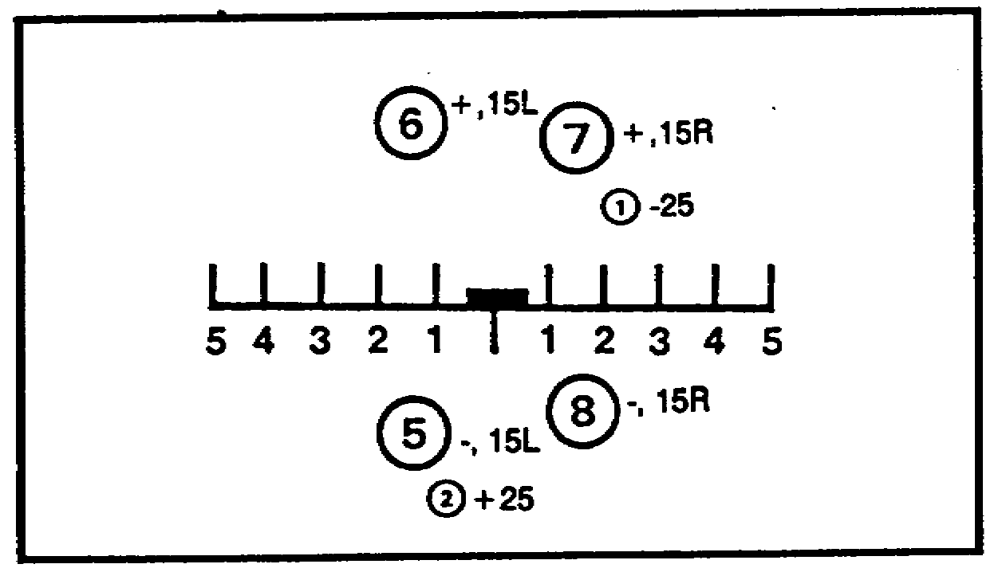

RANGE REFINEMENT DATA ______________

Figure 30.

26

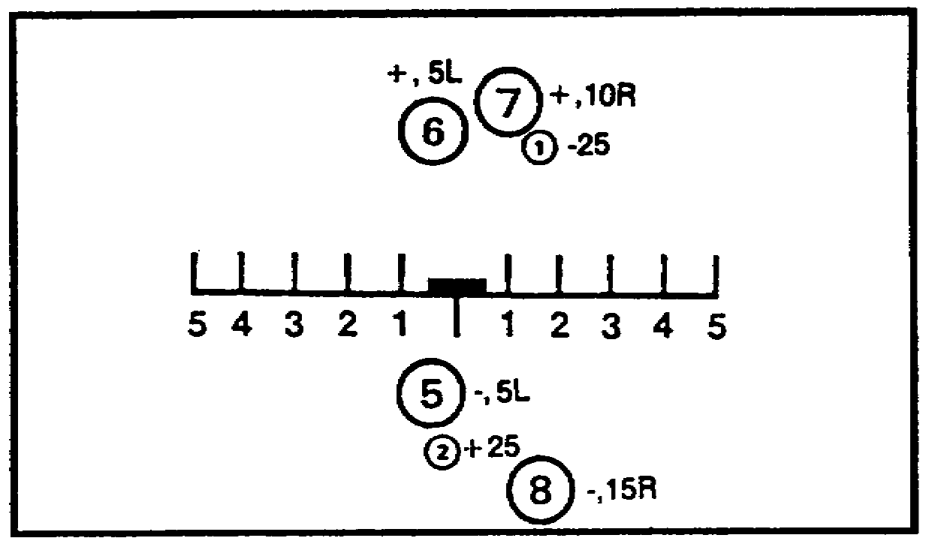

RANGE REFINEMENT DATA ______________

Figure 31.

(1) In Figure 30, the range refinement was add 10. The registration point was equidistant between the two sets of bursts, so we corrected from the last round fired.

(2) In Figure 31, the range requirement was add 20 because the target was further from the last round fired.

c. To determine the range refinement for four rounds is pretty simple, but you may have only three or two rounds to consider. We would have three rounds to consider if one round is spotted short, one round is spotted over, and one round is spotted either target or range correct. Of course all three rounds must be fired with data 25 meters apart. We would have two rounds to consider if both rounds were spotted as target or range correct or one target and one range correct fired with the same data.

27

(1) Look at the situation where three rounds-satisfies the requirement of two overs and two shorts fired with data 25 meters apart. In Figure 32, round five established the lower end of a 25-meter bracket. You called for two rounds, add 25, over. For range, round six is spotted over and round seven is spotted as target. We would not try to refire the range because the target hit counts as an over and a short. We have two overs and two shorts fired with data 25 meters apart, and the registration point is closer to the last round fired.

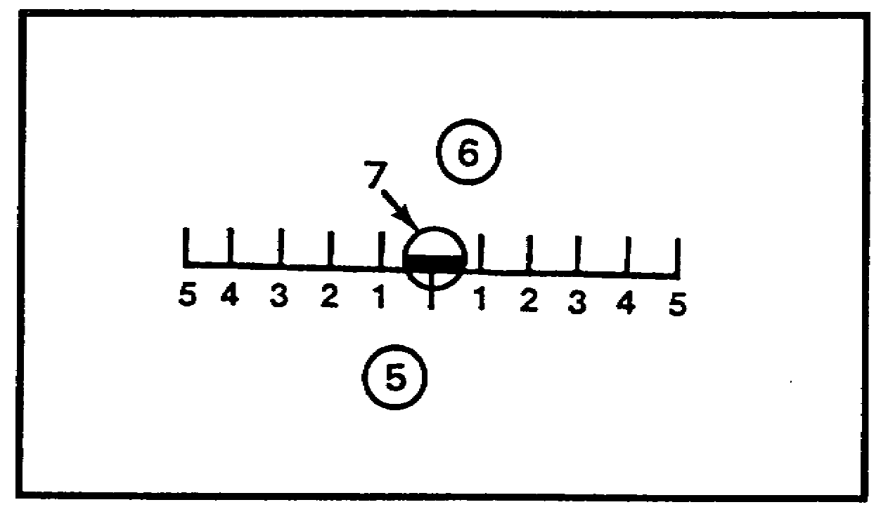

Figure 32.

• Figure 33 shows another three-round situation. Round five is spotted as range correct. You transmit repeat and get a short from round six. You now transmit add 25. Round seven is over. The range refinement is drop 20. The reason for the drop 20 is because the registration point is farther from the last round fired. We have two overs and two shorts because of the spotting of range correct.

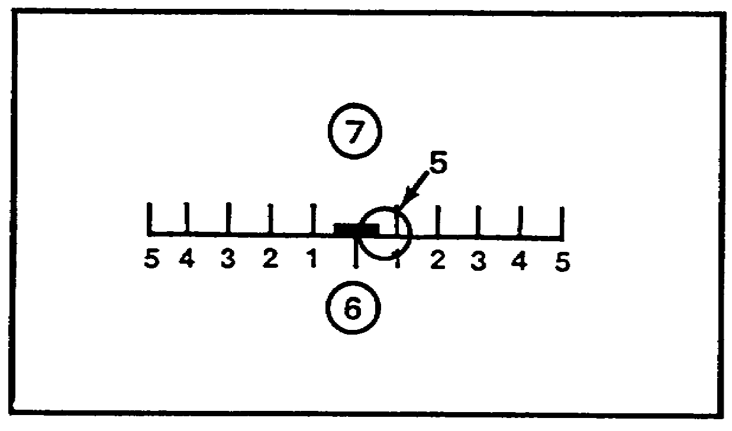

Figure 33.

28

• Figure 34 is one more three-round situation. Round five is spotted as target. You transmit repeat and get an over from round six. You now transmit drop 25. Round seven is short. The range refinement is add 10. When two rounds are equidistant between the two overs and the two shorts, the refinement is 10 meters toward the registration point from the last round fired.

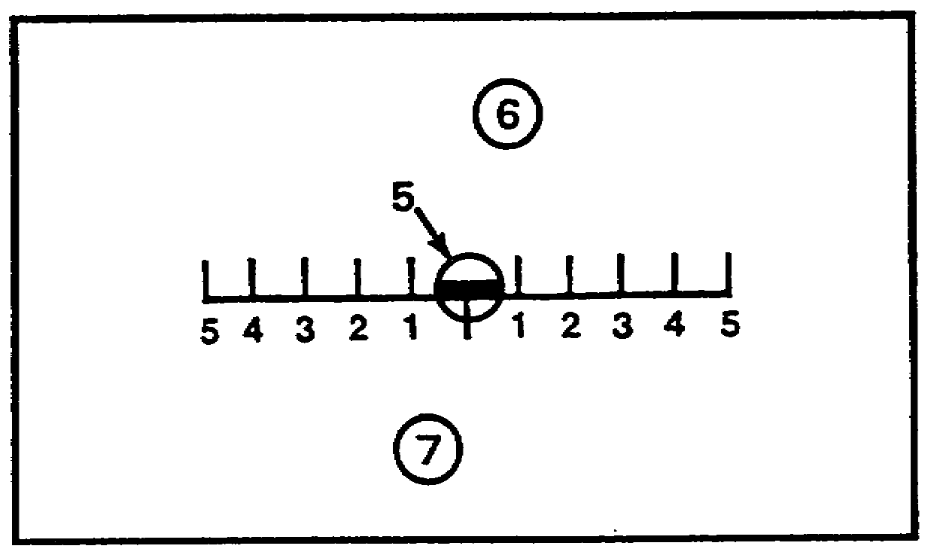

Figure 34.

(2) Look at a two-round situation. There is always the possibility of two target hits or two range corrects or one target hit and one range correct. In Figure 35, round three is a target hit and round four is a range correct. There would not be any range refinement because there is nothing you can do to improve the mean point of impact. The range refinement for the fuze quick registration is determined after the last round of the fuze quick registration is fired. These data are not fired. The data are used at the FDC to make final computations.

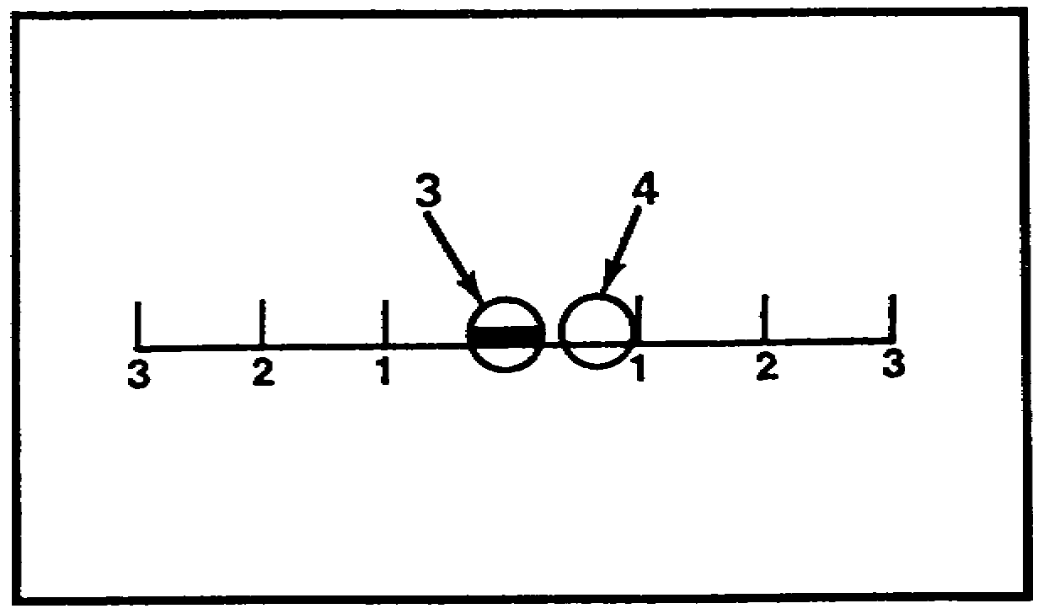

Figure 35.

29

13. DETERMINING DEVIATION REFINEMENT. The deviation refinement is determined by adding the spotting deviations of the rounds establishing the two overs and two shorts (this may include two, three, or four deviation spottings). The total of the spottings is then divided by the number of rounds to get an average deviation expressed to the nearest mil. The average deviation multiplied by the OT factor equals the correction, or as we call it, the deviation refinement.

a. In Figure 36, we will use the same four rounds that we used for range refinement data to determine the deviation refinement. Remember, these were the rounds that gave us our overs and shorts 25 meters apart.

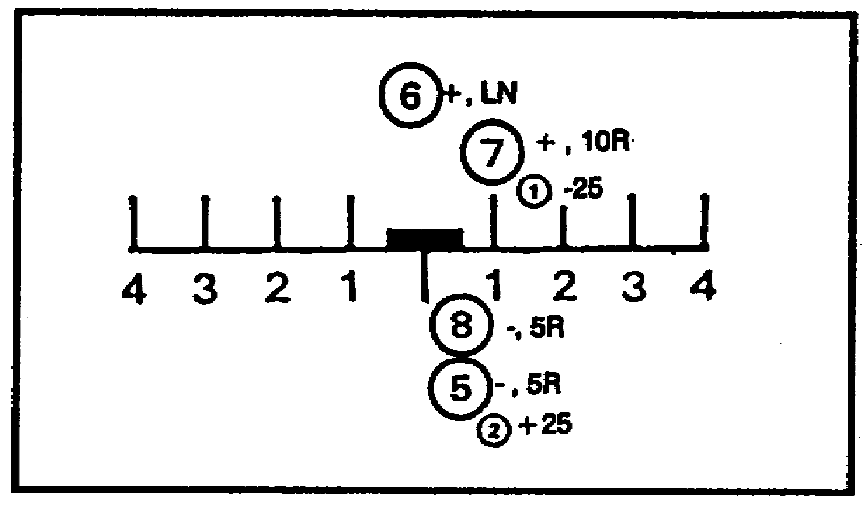

Figure 36.

We determined the total deviation to be 20 mils right--(5) 5R, (6) on line, (7) 10R, and (8) 5R. We divide the total deviation by the number of rounds considered (20 ÷ 4 = 5). We have already determined that the OT factor is two. We multiply the mean deviation (5) by the OT factor (2) to determine the deviation. Our correction is sent to the FDC as left 10. Remember that the correction is sent in the opposite direction from the deviation spotting.

30

PRACTICE EXERCISE:

9. SITUATION: Look at Figure 37 below. Three rounds are considered. In this situation, round five established a 50-meter bracket. You corrected with two rounds, add 25. Round six was spotted as over, 5R, and round seven was target. The OT factor is three.

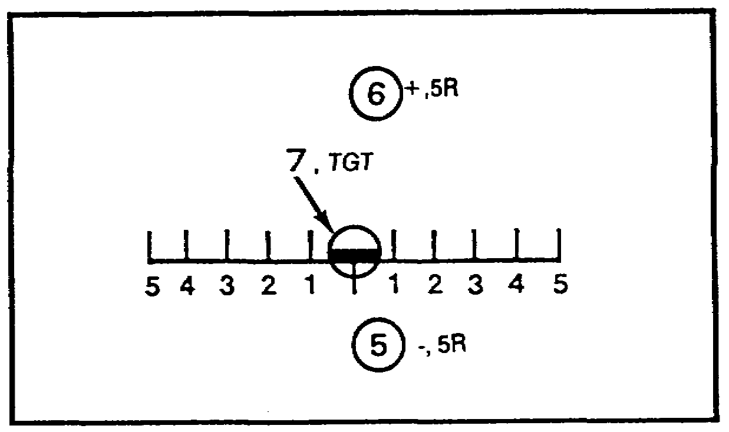

DEVIATION REFINEMENT
Figure 37.

///////////////////////////////////////////////////////////////////////////////

ANSWER:

9. The correction is sent as left 10.

Here is how we got left 10 as the deviation refinement correction to send to the FDC. Round seven counts as an over and a short, so we do not fire another round. The total deviation is right 10-- (5) 5R and (6) 5R. We divide the total deviation by the number of rounds considered(10 ÷ 3 = 3). The mean deviation is multiplied by the OT factor to obtain the amount of refinement (3 x 3 = 9 ≈ 10). Therefore the correction is sent as left 10.

///////////////////////////////////////////////////////////////////////////////

31

b. Now determine the refinement data when only two rounds are considered. We stated earlier in this lesson that a target or a range correct spotting counts as both an over and a short. In Figure 38, round five is a target, so you transmit repeat. Round six is a range correct. The OT factor is two, and the reticle pattern is shown below.

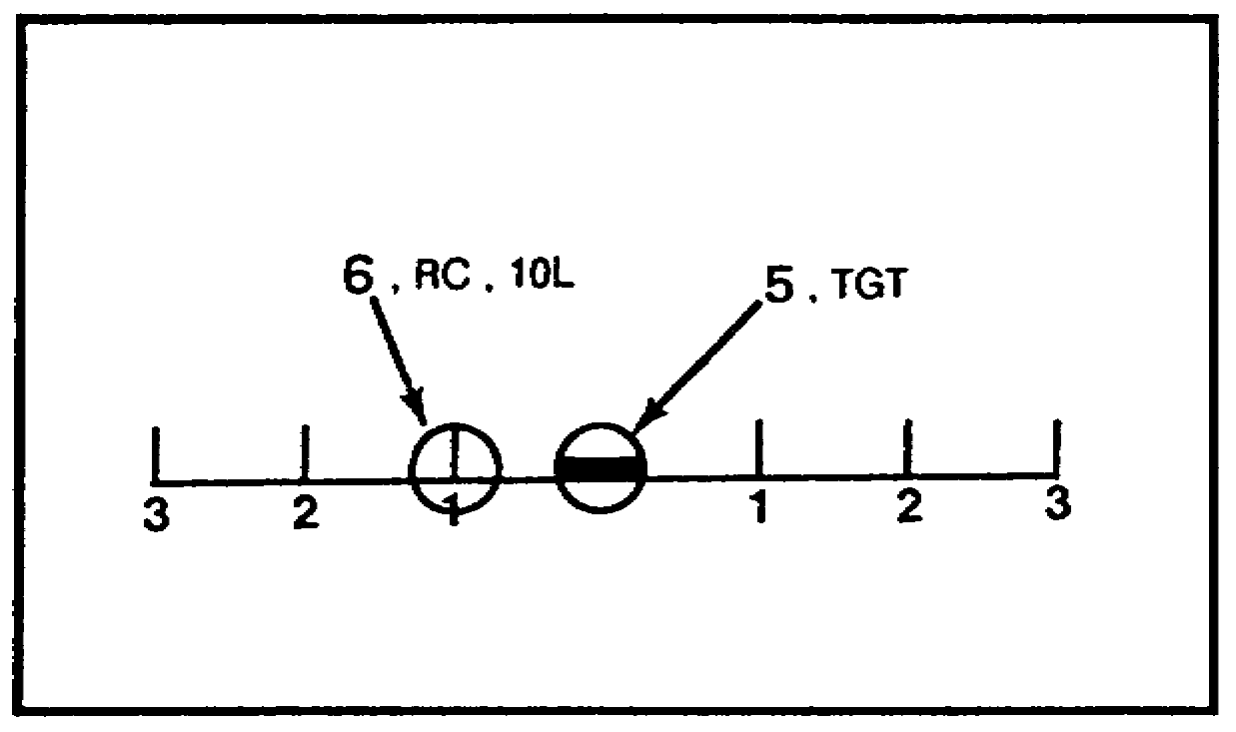

Figure 38.

If you got right 10, you are right on target. Round five is a target and counts as an over and a short. Round six is a range correct and also counts as an over and a short. Divide the total deviation (10) by the number of rounds considered (2) to determine the mean deviation (5). Multiply the mean deviation by the OT factor, and correct toward the OT line.

14. REPORTING DEVIATION AND RANGE REFINEMENT DATA. The deviation and range refinement data for a fuze quick registration are not fired. However, if time fuze is to be fired, as with the time registration, you will fire the refinement data. Here is how you would report the refinement data to the FDC at the end of the fuze quick registration. You transmit LEFT 10, RECORD AS REGISTRATION POINT 1, TIME, REPEAT--OVER. You give the deviation correction if any, the range correction if any, state record as registration point by its number, then request time, repeat--over. Time, repeat is omitted if you are registering only with quick fuze and end of mission--over is added in its place. The fuze or fuzes to be registered are given to you in the MTO.

PRACTICE EXERCISE:

10. SITUATION: You are registering on registration point one, and you will be registering with both quick and time fuzes. The OT factor is two. The last four rounds of fuze quick are shown in the reticle pattern in Figure 39. Determine the refinement data (if any), and write the transmission to the FDC.

32

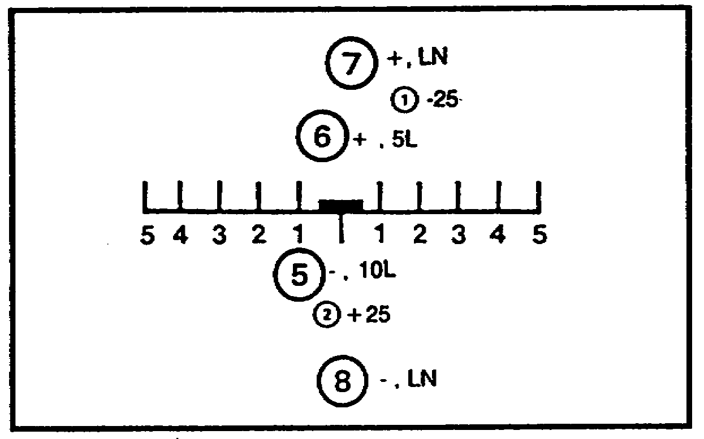

REFINEMENT DATA

TRANSMISSION
Figure 39.

///////////////////////////////////////////////////////////////////////////////

ANSWER:

10. We got right 10, add 20, record as registration point one, time repeat--over. Here is how we got the refinement data. The total deviation is 15 mils left. Divide this by the number of rounds considered, in this case four (15 ÷ 4 = 3.7 ≈ 4). Next, multiply the mean (4) by the OT factor (2), and correct toward the registration point (right 10). The registration point is farther from the last round fired; therefore, we add 20.

///////////////////////////////////////////////////////////////////////////////

33

15. FUZE TIME REGISTRATION. When you have completed the fuze quick registration and transmitted TIME REPEAT OVER, the next burst you observe is a time-fuzed round. This burst may be either a graze burst or an airburst. If the round strikes the ground before the time mechanism functions, the round bursts on impact. Its appearance is the same as that of a round fuzed with a quick fuze. Figure 40 shows a time-fuzed round that resulted in an impact burst. Figure 41 shows a time-fuzed airburst. An airburst can be identified by a ring of black smoke around a flash of fire. These figures do not show the flash of fire, only the black ring of smoke. Depending on your spotting (air or graze) for the initial time-fuzed round, you would make one of the following transmissions:

• UP 40, OVER. If your first round is a graze burst, the up 40 should result in an airburst. If the next burst is once again spotted as a graze, you must transmit UP 40, OVER. This is continued until a burst is spotted as an air.

• AIRBURST. If your first round is spotted as an air, you transmit THREE ROUNDS, REPEAT, OVER.

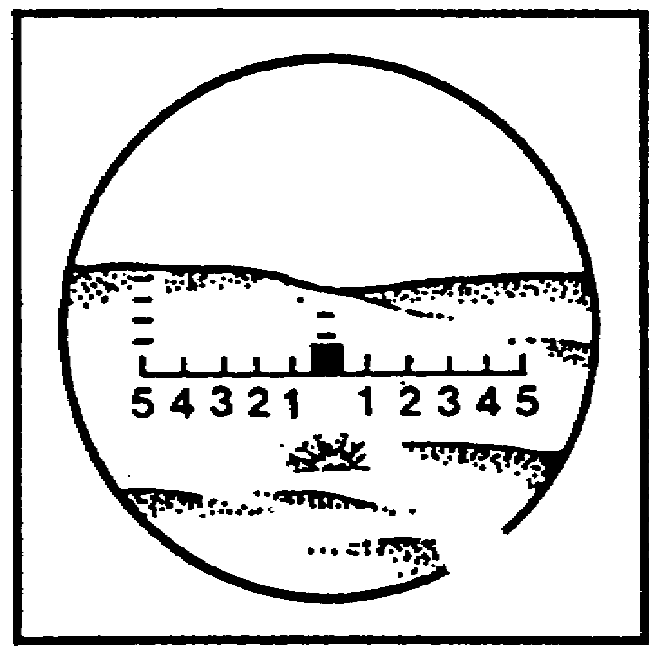

Figure 40.

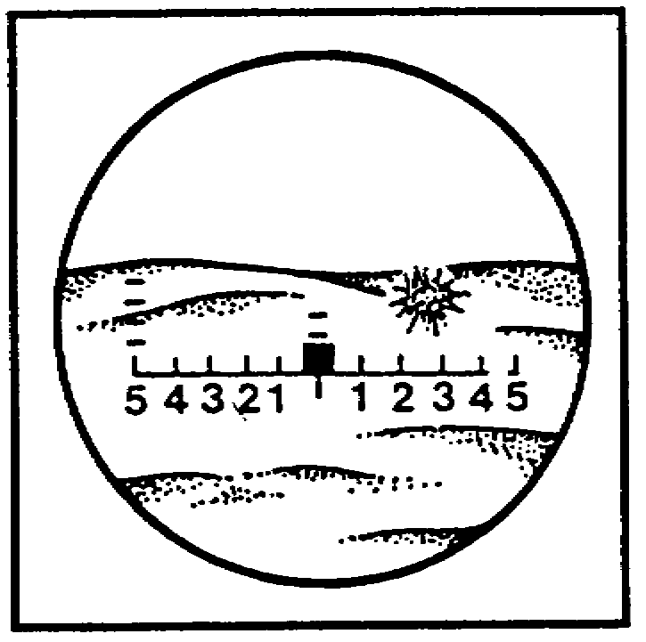

Figure 41.

34

When you spot an airburst, whether it is the result of up 40 or the initial round, you transmit THREE ROUNDS, REPEAT, OVER. The time registration is similar to the quick registration in that both must have four usable rounds. The only difference is the type of fuze being fired. In the time registration, at least one round must be spotted as an air. You are concerned with refinement data which would result in a 20-meter height of burst (HOB). You, therefore, ignore range and deviation. You are concerned only with the fuze section. In other words, is it a graze or is it an air? Your first usable spotting must be an air. This round plus the three rounds, repeat results in one of the following combinations:

• One air, three graze or

• Two air, two graze or

• Three air, one graze or

• Four air, zero graze

The refinement data that can be determined for each combination are shown in Table 3. Memorize these combinations because they are the keys to the time registration.

Table 3.

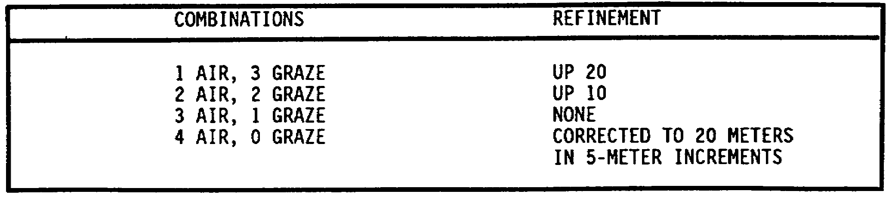

35

We are going to look at three separate missions that are shown in Figures 42 through 44. The initial round is shown at the left and the succeeding three rounds at the right. In the spaces provided, write the refinement data for each situation.

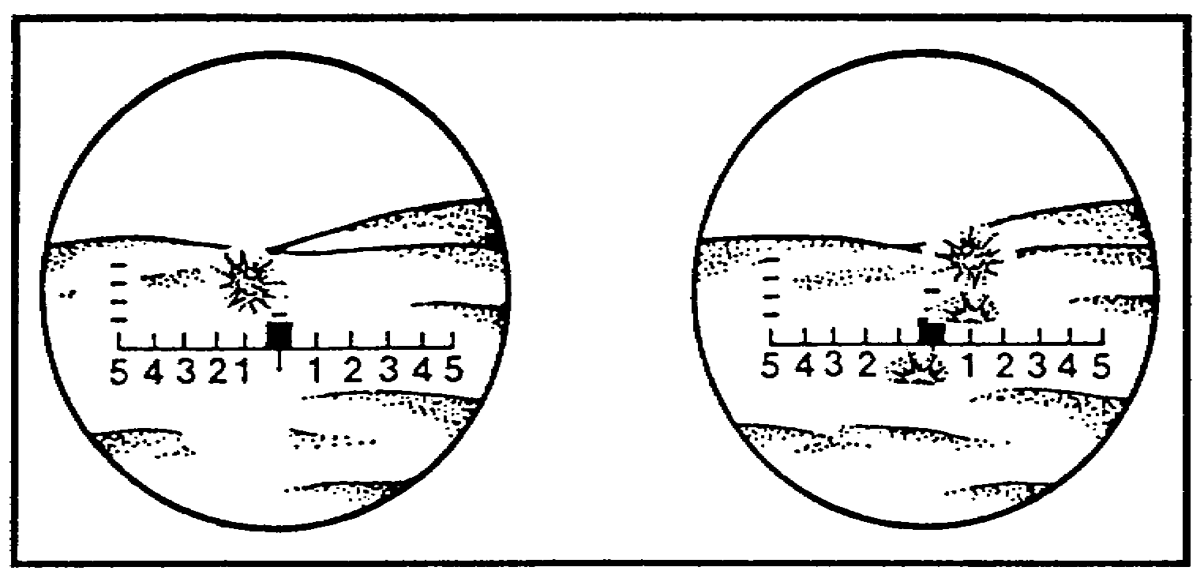

Figure 42.

Figure 43.

REFINEMENT
DATA

REFINEMENT
DATA

36

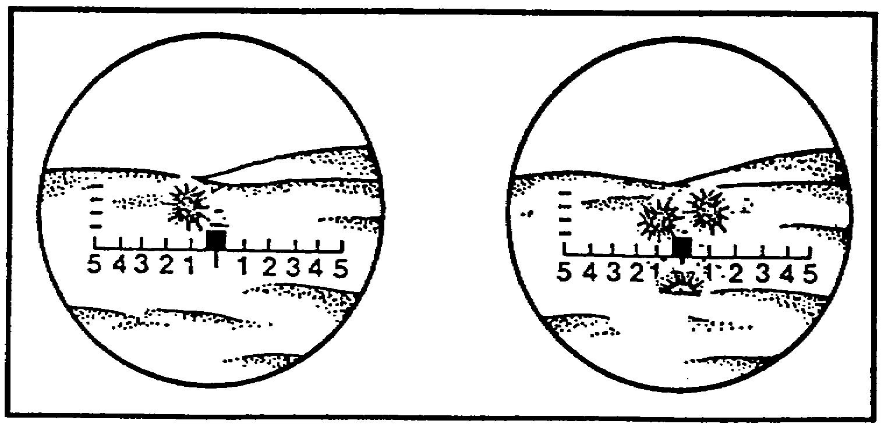

Figure 44.

REFINEMENT
DATA

Here is what we got:

• Up 10 for Figure 42.

• Up 20 for Figure 43.

• None for Figure 44.

If you are having problems with the time registration, you need to review before proceeding with the lesson.

16. DETERMINING HOB DEVIATION CORRECTION. The HOB deviation spotting is always measured to the nearest 1 mil. You must keep track of your spottings. We suggest that you record them on the same sheet of paper that you used for the fuze quick registration. Earlier, we stated that the first usable round must be an air. The remaining three rounds can be either air or graze. The HOB deviation for the first air round must be recorded either on your sheet of paper or in your head. Also, we said that a combination of four air and zero graze rounds was corrected to 20 meters in 5-meter increments. To determine the refinement, you must do the following:

a. Determine the mean HOB by adding the mil deviations from each of the four rounds and then dividing by four.

b. Multiply the mean HOB by the OT factor and express to the nearest 5 meters.

c. Determine the refinement (up or down so much) by comparing the mean HOB with 20 (the desired HOB).

37

(1) Here is an example of how to determine the correction for four airbursts. The OT factor is three, and the rounds burst as follows:

Round 1--Air, 8 mils

Round 2--Air, 11 mils

Round 3--Air, 10 mils

Round 4--Air, 12 mils

• Determine the mean HOB by adding the mil deviations from each of the four rounds (8 + 11 + 10 + 12 = 41) and dividing by four (41 ÷ 4 = 10).

• Multiply the mean HOB (10) by the OT factor (3) and express to the nearest 5 meters (10 x 3 = 30).

• Determine the refinement by comparing the mean HOB (30) to the desired HOB (20). In this case, our mean HOB is higher than our desired HOB. Therefore our refinement is down 10.

(2) Do you think you can do one? Let us find out. Here are the four rounds that are considered, and the OT factor is three. When you are finished, compare your answers with ours below.

Round 1--Air, 9 mils

Round 2--Air, 16 mils

Round 3--Air, 8 mils

Round 4--Air, 12 mils

Write your refinement data here ______ ______ .

We got down 15. Here is how we did it. The mean HOB is 11 (45 ÷ 4 = 11). Multiply this by the OT factor (11 x 3), and express the answer to the nearest 5 meters (11 x 3 = 33 ≈ 35). Next, compare the mean HOB (35) with the desired HOB (20), and get a refinement of down 15.

d. When refinement data are determined, you report them to the FDC and
end the mission. If you do not report any refinement, the FDC knows that the mean
height of burst is 20 meters (the desired HOB). Using the down 15 determined on
the last exercise, the transmission would be DOWN 15, RECORD AS TIME
REGISTRATION, END OF MISSION, OVER.

38

17. SUMMARY. When conducting a precision registration, you should keep in mind that the bracket is reduced until you split a 50-meter bracket, spot a range correct, or spot a target hit. Therefore, it is very important that you keep track of where each round impacted with respect to the registration point. I suggest you make a sketch of a reticle pattern on a sheet of paper. This helps you keep track of your rounds. Also, remember that the rounds are spotted to the nearest 1 mil and corrected to the OT line before splitting the 200-meter bracket. Finally, during refinement you are looking for two overs and two shorts along the OT line fired with the same data or with data fired 25 meters apart.

39

THIS PAGE INTENTIONALLY LEFT BLANK

40

Lesson 3
CONDUCT A MORTAR PRECISION REGISTRATION

OBJECTIVE

Upon completion of this lesson, you will be able to conduct a mortar precision registration.

REFERENCES

This lesson is based on FM 6-30 and other materials approved for US Army field artillery instruction; however, development and progress render the text continually subject to change. Therefore, base your examination answers on material presented in this text rather than on individual or unit experience.

18. INTRODUCTION. In the two previous lessons, we discussed reference points, selecting and locating targets, and precision registration with the impact and time method. The precision registration procedures for mortars are almost identical to the impact registration procedures for artillery. The exception is that once a 50-meter range bracket has been split and the last fired round is within 25 meters of the target, refinement corrections are sent to the FDC and the mission is ended. Also, only one round over and, one round short are required However, a good observer should be able to adjust any type of round on a target.

19. CALL FOR FIRE. Once you have located an adjusting point, the enemy, and the friendly units, the next step is to call for fire. The call for fire is a concise message prepared by the FO to tell the FDC who, what, where, and when in reference to the target. Whether you are adjusting mortars or artillery, the call for fire is basically the same. The call for fire must be sent rapidly, but with enough clarity to be understood, recorded, and read back without error by the FDC radiotelephone operator (RATELO). Information is sent to the FDC as it is being determined, rather than waiting until a complete call for fire is prepared. Regardless of the method of target location being used, the normal call for fire is transmitted in a maximum of three parts, with a break and a read back after each part. The three parts of the call for fire are:

• The observer location and the warning order.

• The target location.

• The description of the target, the method of engagement, and the method of fire and control.

Within the three parts of the call for fire are six very important elements. The six elements are covered briefly in this lesson. If you need more information, you may take TEC Lesson 949-061-0004-F, The Call for Fire. The six elements in the sequence in which they are transmitted are listed below.

• Observer identification. This element of the call for fire lets the FDC know who is calling for fire and clears the net for the fire mission.

41

• Warning order. This element informs the FDC of the type of mission and the type of target location that will be used.

• Target location. This element enables the FDC to plot the location of the target to determine firing data.

• Target description. In this element, the observer must describe the target in enough detail so that the FDC can determine the amount and type of ammunition to use.

• Method of engagement. In this element, the observer must indicate how he wants to attack the target.

• Method of fire and control. This element indicates the desired manner of attacking the target, whether or not the observer desires to control the time of delivery of fire, and whether or not he can observe the target.

Figure 45 shows an example of a call for fire. Always keep in mind that the call for fire is transmitted in three parts with a break and a read back after each part.

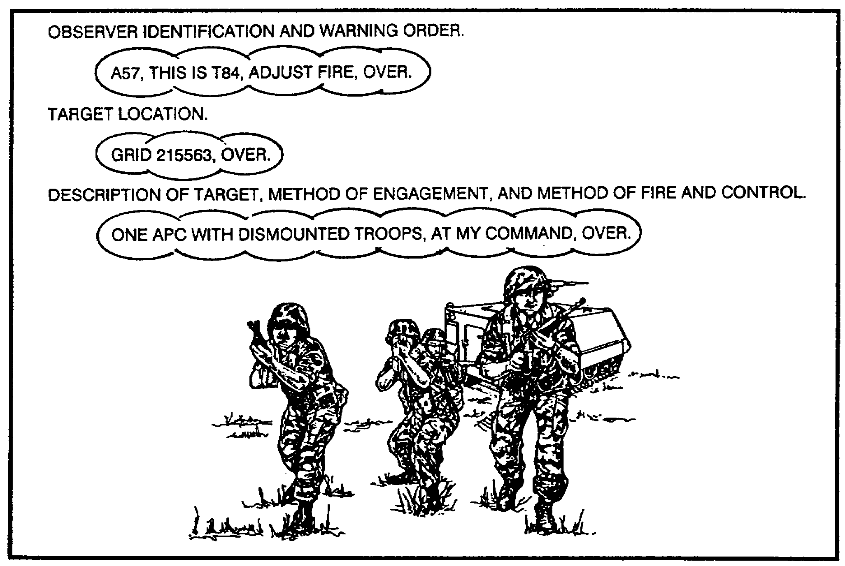

Figure 45.

42

b. The call for fire shown above is just one example of how it could be sent. There are many different ways of sending a call for fire, but the formats are all the same when it comes to the three main parts.

20. TARGET LOCATION. There are three methods of target location available to the observer. We have already said the target location enables the FDC to plot the target to determine firing data, but there is a little more to it than that.

Let us examine each method one at a time.

a. Grid coordinates. In a grid mission (targets located by grid coordinates), six-place grids are normally sent. In this lesson, we are talking about precision fire and precision fire calls for eight-place grids. Therefore, for the precision registration mission with mortars, all grid-located targets are sent as eight-place grids. The direction to the target (OT direction) is sent to the FDC as soon as it is determined. If it is not sent in the call for fire, it must be sent before or with the first correction. Normally, the OT direction is sent after the entire call for fire is completed, since the FDC does not need it to locate the target.

b. Shift from a known point. If the target is located by a shift from a known point; the point must be known to both the observer and the FDC. The OT direction is sent in the call for fire to the nearest 10 mils; however, the FDC can handle mils, degrees, or cardinal directions. The lateral shift (how far left or right the target is from the known point) is sent to the nearest 10 meters, and the range shift is sent to the nearest 100 meters. If there is a vertical shift sent to the FDC, it is sent to the nearest 5 meters. Unless there is an obvious difference in altitude, the vertical shift is ignored.

c. Polar plot. The last method of target location that the observer may use is the polar plot mission. In the polar plot mission, the word POLAR must be included in the warning order. This alerts the FDC that the target will be located with respect to the observer's location. The OT direction is sent to the nearest 10 mils, and the distance is sent to the nearest 100 meters. A vertical shift to the nearest 5 meters tells the FDC how far the target is located above or below the observer's location.

21. OT FACTOR. Now that you have located the target and have sent the call for fire to the FDC, the next step is to determine the OT factor. If it is necessary, review Lesson 2.

PRACTICE EXERCISE:

11. Express the OT distances below, and then determine the OT factor for each distance.

OT DISTANCE NEAREST 1,000 OT FACTOR

a. 1,500

b. 650

c. 4,500

43

///////////////////////////////////////////////////////////////////////////////

ANSWERS:

NEAREST 1.000 OT FACTOR

11. a. 2,000 2.0
b. 600 0.6
c. 4,000 4.0

///////////////////////////////////////////////////////////////////////////////

22. SPOTTINGS. Now that you know how to determine the OT factor, store it in the back of your head for a few minutes. You are going to have to use it again in the next paragraph, but first you have to learn about spottings. Whenever you see a round burst in the target area, you immediately make a spotting of where the round bursts in relation to the target on which you are adjusting. Observer spottings are made for range (whether the burst was over, short of, or at the Same distance as the target) and deviation (the number of mils the round bursts to the left or right of the target). Of all the types of range spottings you may observe, only three of them are considered definite spottings. That means you can definitely tell where they burst. The three types of range spottings that are considered definite range spottings are over, short, and range correct. Figure 46 shows what these three types of spottings may look like in a target area as seen through the binoculars.

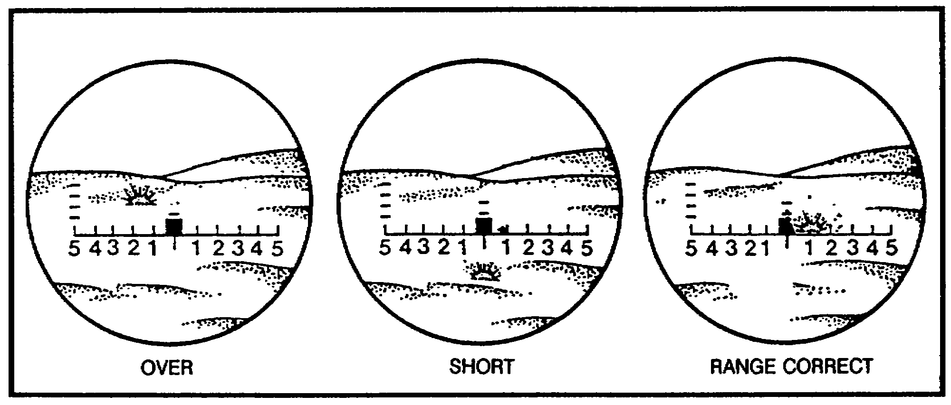

Figure 46.

44

When you are conducting an adjustment on the target, you should establish a range bracket as early in the adjustment as possible. When the first definite range spotting is made, you make a range correction that causes the next round to be spotted opposite that of the previous round. For example, if the first definite range spotting is short, the next correction of add so much should be sent to the FDC to obtain an over spotting on the next round. You then cut each range correction in half, successively moving each round closer to the target. Procedures for precision registration with the mortars are the same as the impact procedures for artillery except that once the 100-meter range bracket has been split and the last fired round is within 50 meters of the target, refinement corrections are sent to the FDC, and the mission is ended. Range corrections are made to the nearest 25 meters for refinement data.

23. DEVIATION SPOTTINGS. The next type of spotting you make is the deviation spotting. This is simply a determination of whether the round burst left or right of the target and how far. Deviation spottings are made in relation to the OT line. There are three types of deviation spottings. They are left, right, and line. Figure 47 shows what these spottings might look like.

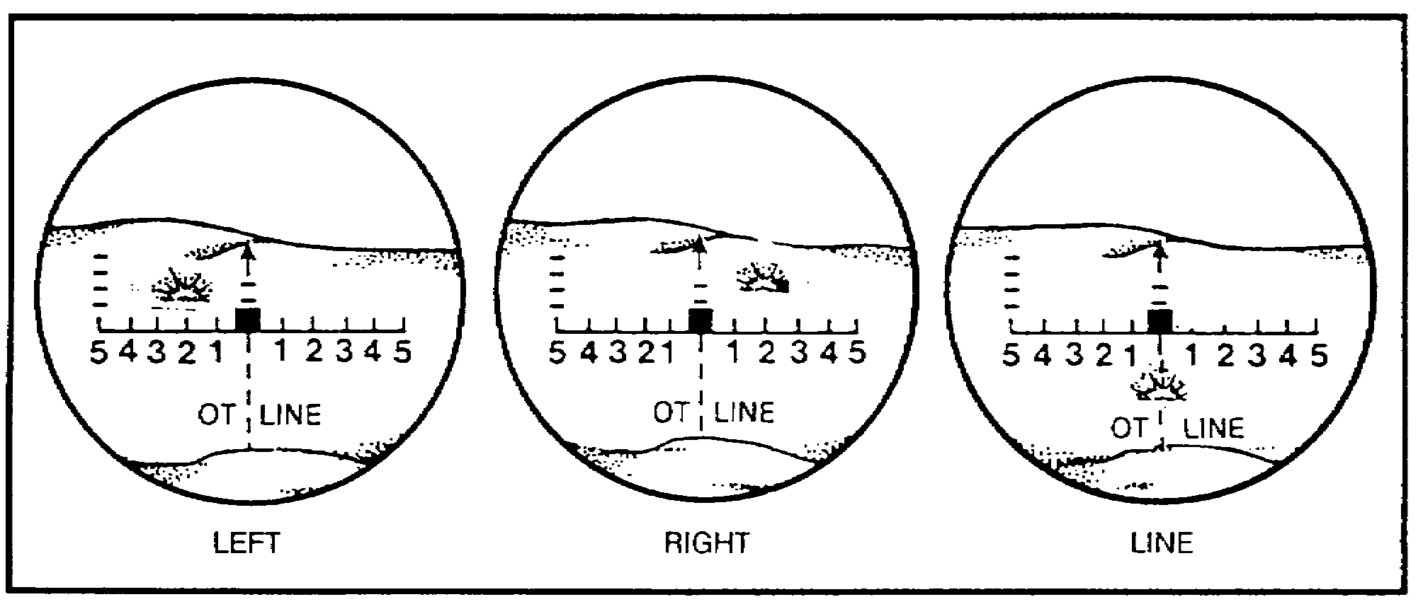

Figure 47.

45

When you spot a burst as being left or right, you must measure how far left or right the burst is, in mils. These measurements are made to the nearest 5 mils. There are several methods of making deviation measurements, but we will only use the binocular reticle pattern in this lesson. The horizontal scale of the reticle pattern is used to make deviation measurements. The reticle pattern in the scale is shown in Figure 48.

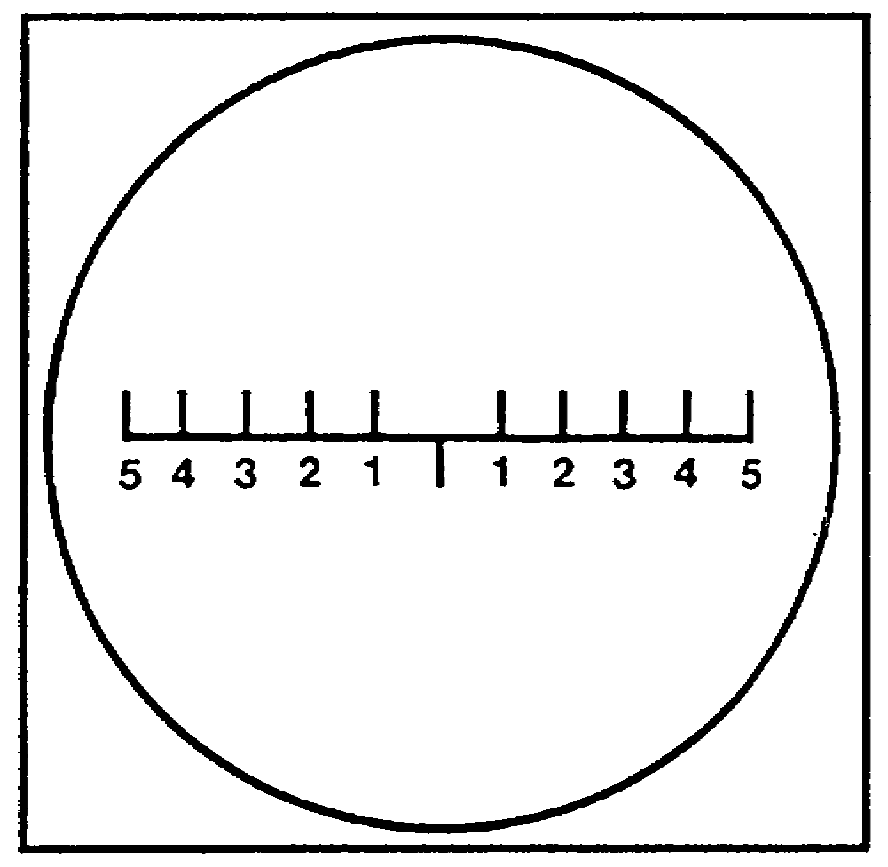

Figure 48.

46

The scale is numbered every 10 mils, starting in the center and going out both directions to 50 mils. The numbers on the bottom of the scale must be multiplied by 10 to obtain the correct mil reading. If the burst is halfway between the numbers, it will have to be estimated to 5 mils. The range and deviation spottings are simply your mental note of where a round bursts. Until you have experience at making these spottings, you may want to write them down or say them aloud. Let us look at some examples of what a range and deviation spotting look like. Figure 49 shows a range spotting as it appears in the binocular. We align the horizontal scale with the bottom edge of the target. The burst is definitely over the target, so our range spotting is over. Figure 50 shows a deviation spotting as it would appear. Once again, align the bottom edge of the scale on the target. The burst appears to the left and in line with the mark numbered 3. Our deviation spotting is 30 left.

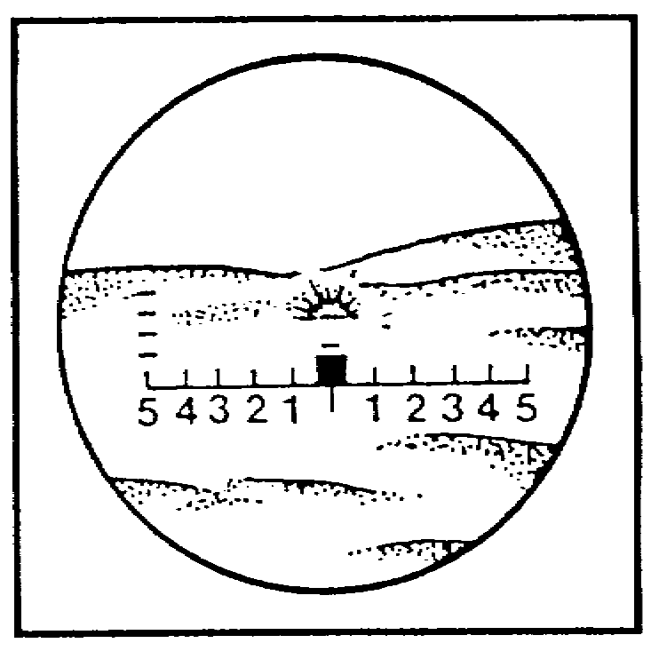

Figure 49.

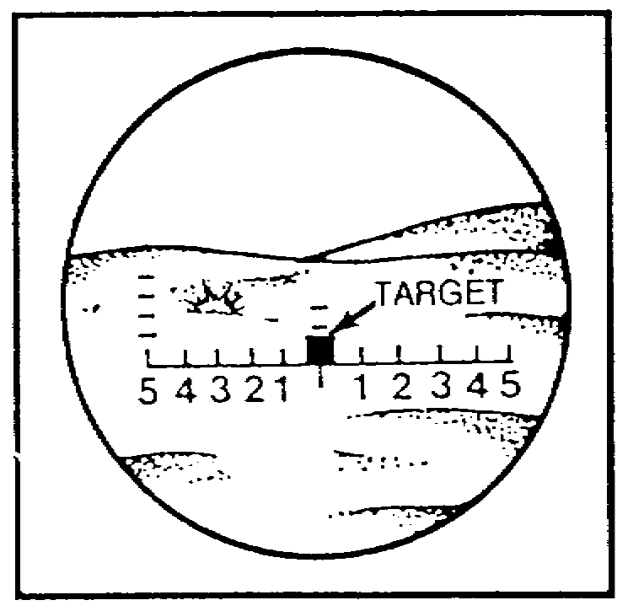

Figure 50.

47

PRACTICE EXERCISE:

12. Let us find out how much you have learned. Write the range and deviation spottings for each of the rounds below.

a. b. c.

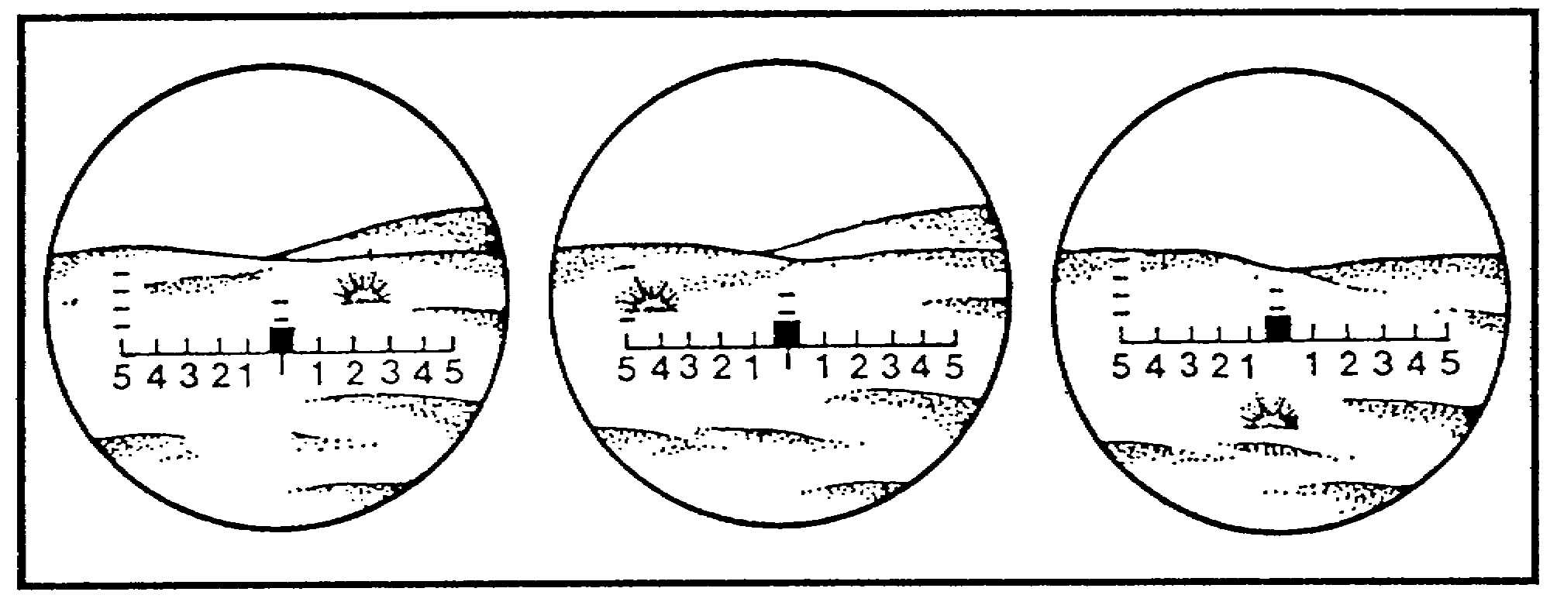

///////////////////////////////////////////////////////////////////////////////

ANSWERS:

12. a. Over, 20 Right
b. Over, 40 Left
c. Short, 5 left

///////////////////////////////////////////////////////////////////////////////

24. DEVIATION CORRECTIONS. When we combine the OT factor with the spottings, we come up with a deviation correction that can be used by the FDC to move the burst of the round. You simply tell the FDC the direction and distance, in meters, that the burst needs to be moved to bring it in line with the target or OT line. If you spot a burst as being left of the target, you must correct it to the right to bring it in line with the target or OT line. If you spot a burst as right, you must correct it to the left. If you have a spotting of line, you will not have a deviation correction because the burst is already correct as far as deviation is concerned.

a. Now let us see how to determine the deviation correction so that the FDC can use it. To convert your deviation spotting measurement in mils to a deviation correction in meters, multiply the OT factor by the number of mils in your spotting.

EXAMPLE: Our OT factor is three, and our deviation spotting is 20 right. The correction that is sent to the FDC is left 60. The spotting was to the right, so we must correct to the left. We must move the round 60 meters (3 x 20 = 60).

48

Deviation corrections are sent to the nearest 10 meters; however, corrections of 20 meters or less should not be sent during the adjustment phase. Look at Figure 51, and see how we determined the complete deviation correction that is sent to the FDC.

The OT distance is 2,500 meters.

The spotting is 25 right.

The correction is left 50.

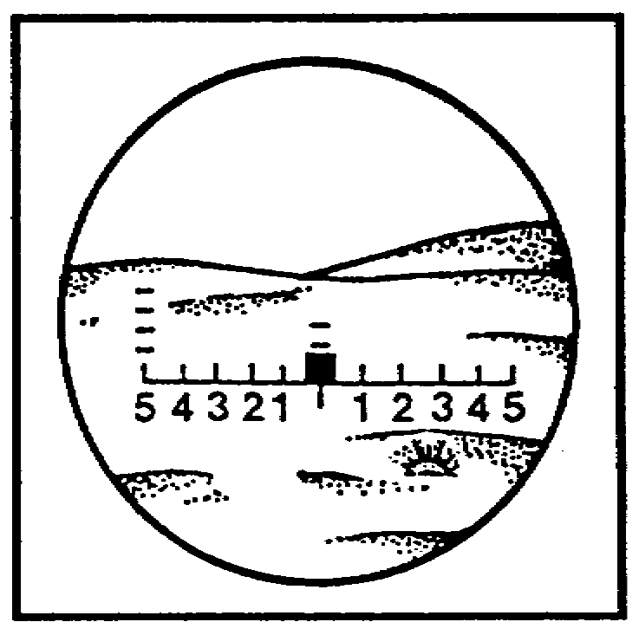

Figure 51.

We multiplied the OT factor of two by the number of mils we measured for the spotting (25) and corrected towards the target.

b. As we said earlier, the procedures for registration with a mortar are almost identical to the impact procedure with artillery. Here are some points to remember before we get into range corrections.

• Make deviation corrections to move the rounds in line with the target.

• Convert spottings in mils to corrections in meters by multiplying the number of mils by the OT factor.

• Make deviation corrections to the nearest 10 meters.

• Send deviation corrections to the FDC before range corrections.

25. RANGE CORRECTIONS. Experience and knowledge of the terrain in the target area help the observer to make accurate range spottings. You must have definite range spottings before you can make a range shift. The precision registration procedures for the mortars are identical to the impact registration procedures for artillery except that once a 100-meter range bracket has been split and the last round fired is within 50 meters of the target, refinement corrections are sent to the FDC, and the mission is ended. Range corrections are made to the nearest 25 meters. One more step that is not done for artillery, but may be required for mortars, is adjusting the sheaf. This procedure is covered later in this lesson. Right now we will look at an example of the last two rounds fired

49

in the mortar registration (see Figure 52). Round six is fired with data that split the 100-meter bracket. The transmission to the FDC that follows round six is drop 50, over. Observe round seven, and compare it with the registration point and the previous burst (round six).

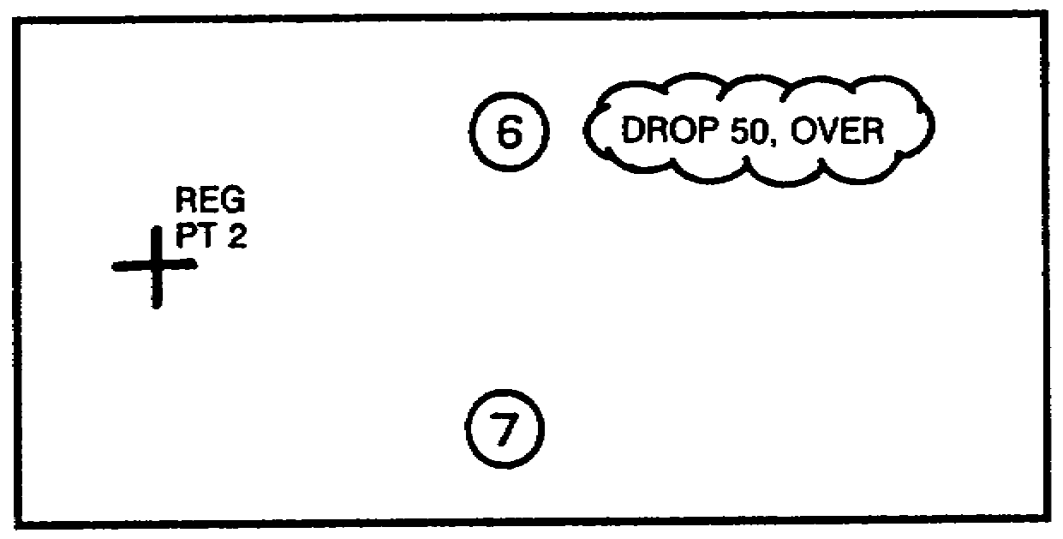

Figure 52.

In the example above, round seven is 25 meters short of the registration point and is 20 meters to the right. The burst must be moved 20 meters to the left and 25 meters must be added to the range to hit the registration point (see Figure 53).

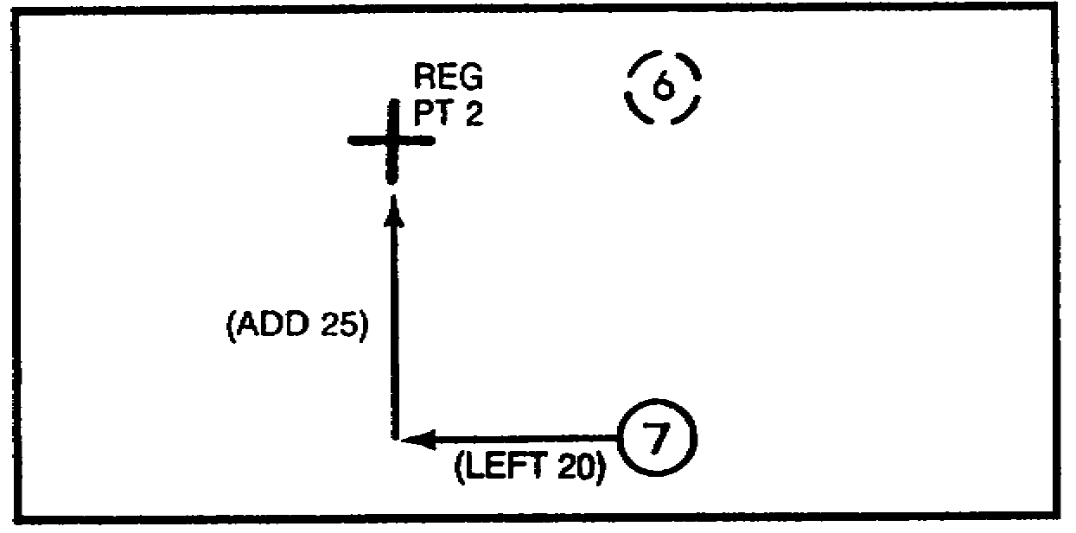

Figure 53.

The last round fired (round seven) is within 50 meters of the registration point, so the following transmission is sent to the FDC:

LEFT 20, ADD 25, RECORD AS REGISTRATION POINT 2, END OF MISSION, OVER.

The left 20, add 25 are the refinement corrections the FDC must have to move the round onto the registration point. The record as registration point two, end of mission, informs the FDC that the mission has been completed. Wait for a read back from the FDC to ensure that the data are correctly received before going on to a new mission.

50

PRACTICE EXERCISES:

13. Before you can make a range shift, you must have ________ ______
spottings.

14. Refinement corrections are sent to the FDC when the last round is fired within ____________ meters of the registration point.

///////////////////////////////////////////////////////////////////////////////

ANSWERS:

13. definite range
14. 50

///////////////////////////////////////////////////////////////////////////////

26. ADJUSTING THE SHEAF. The extra step that is not done for artillery, but may be required for mortars, is adjusting the sheaf. This may be done anytime during a fire mission, but normally is done after completion of the registration. If the sheaf is to be adjusted, it is directed by the FDC. The FDC sends:

PREPARE TO ADJUST THE SHEAF, OVER.

a. The purpose for adjusting the sheaf is to get all mortars firing parallel. The mortars are positioned with numbers one through three from right to left for the 81-mm mortars and with numbers one through four from right to left for the 107-mm mortars. To start the adjustment of the sheaf, the observer selects the adjusting points at the same range (within 50 meters) as the registration point. The rounds are adjusted on line with a 40-meter lateral spread between them. The mortar that was used to register does not fire the mission. The mission begins when the observer requests:

SECTION RIGHT (or LEFT) REPEAT, OVER.

b. The remaining mortars then fire in order, starting at the right (or left), with 10-second intervals between rounds. Assume that we are adjusting the sheaf of a 107-mm mortar section and we have already selected the adjusting point. The next step would be to select the order in which we want the mortars to fire. If we want to start firing with the number one mortar (the right mortar) and then follow with numbers three and four, we would transmit the following message to the FDC:

51

SECTION RIGHT, REPEAT, OVER.

c. All rounds are adjusted perpendicular to the gun-target line, and all range corrections for rounds impacting within 50 meters of the sheaf line are ignored. The desired location of the number one mortar round would be to the right of the registration point, and numbers three and four would be to the left. An example of the location of the adjusting points with respect to the registration point is shown in Figure 54.

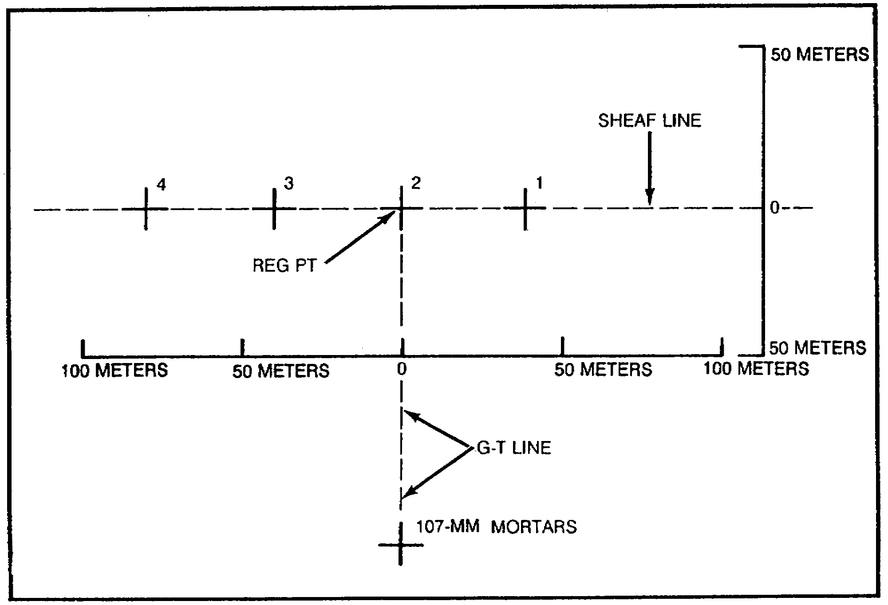

Figure 54.

The figure above shows the desired locations of the bursts, and each round, as it is fired, is adjusted to these locations. Remember these three very important points as you are making your adjustments.

• Adjust all rounds on line at about the same range (within 50 meters) and with 40 meters lateral spread between rounds.

• Ignore range corrections for rounds impacting within 50 meters of the sheaf line.

• Adjust the sheaf perpendicular to the gun-target line.

52

If you have to make any lateral refinement corrections, they are made to the nearest 10 meters. Lateral refinement corrections of less than 50 meters are not fired. When all refinement corrections (range and lateral) for all mortars have been determined, the sheaf is adjusted.

d. Figure 55 shows the desired locations of the bursts and the bursts from the numbers one, three, and four mortars. Refer to this figure as we go through the adjustment phase together. Using the binoculars, observe each round as it impacts, and record its spotting on a piece of paper. The rounds should be impacting 10 seconds apart. Therefore, you have plenty of time to write down your spottings. When you have the spottings for all mortars written down, compare them with the desired burst locations. If any of the mortars need to be adjusted, transmit the adjustment data before sending the refinement data. Remember that the bursts must be less than 50 meters in deviation and range from the desired burst locations before they can be considered as adjusted. If one or more mortars exceeds these ranges, the mortar or mortars must be adjusted individually until they are within the desired locations (less than 50 meters from the desired burst location).

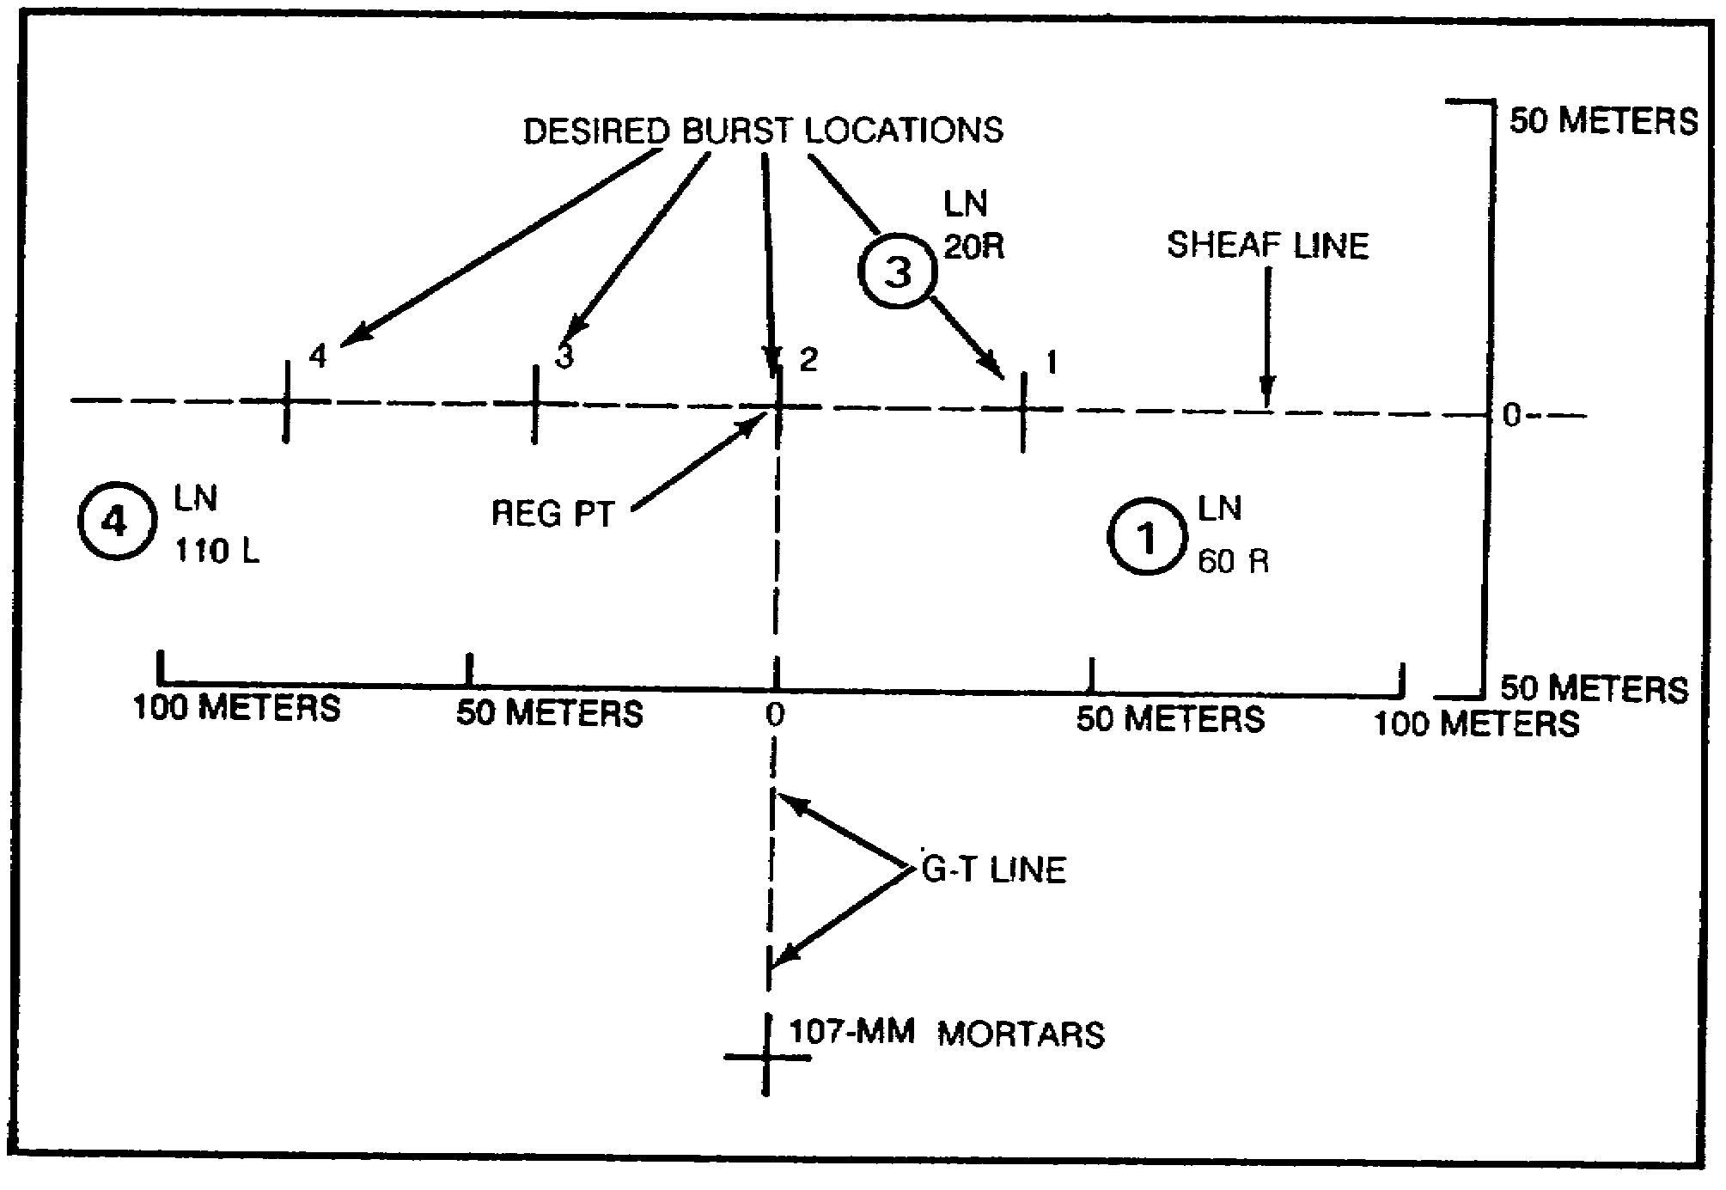

Figure 55.

In the figure above, round one is within 50 meters in range and must be moved left 20 to the desired burst location. Round three is within 50 meters in range and must be moved left 60 to the desired burst location. Round four is within 50

53

meters in range and must be moved right 30 to the desired burst location. Since round three is more than 50 meters out in lateral adjustment, transmit the following adjustment for it to the FDC:

NUMBER 3, LEFT 50, REPEAT, OVER.

As soon as you get a read back of the adjustment for round three from the FDC, you can send the refinement for round one and round four as follows:

NUMBER 1, LEFT 20, NUMBER 1 IS ADJUSTED; NUMBER 4, RIGHT 30, NUMBER 4 IS ADJUSTED, OVER.

When you observe the burst of round three, make the spotting on your paper and then transmit the refinement data to the FDC (provided no further adjustments are needed). For example, the round bursts 10 meters left of the desired burst location and within 50 meters in range, so you would transmit:

NUMBER 3, RIGHT 10, NUMBER 3 IS ADJUSTED, OVER.

After you receive a read back from the FDC and the sheaf is properly adjusted, transmit:

SHEAF IS ADJUSTED, END OF MISSION, OVER.

27. SUMMARY. During the mortar registration, we did basically the same thing as we did in the previous lesson. There was the exception of splitting the 100-meter bracket, and if the last round fired is within 25 meters of the target, refinement corrections are sent to the FDC and the mission is ended. Finally, the FDC may want to adjust the sheaf to get all mortars firing parallel. This can be done during the fire mission, but may be directed by the FDC after the registration.

54

FA4230-8
Jun 88

EXAMINATION

CONDUCT A PRECISION REGISTRATION WITH ARTILLERY AND MORTAR

This examination consists of 30 questions. Answer all questions on the enclosed ACCP Examination Response Sheet (TSC Form 59). Individual work on the exam is mandatory. After completing the examination, place the answer sheet in the self-addressed envelope provided and mail it to the Institute for Professional Development (IPD) for grading. IPD will send you a copy of your grade for this examination.

1. The FO determines direction to reference points and registration points to the nearest--

a. 1 mil.
b. 10 mils.
c. 20 mils.
d. 100 mils.

2. A good reference point must be--

a. easily identifiable.
b. large in size.
c. on top of hills.
d. close to the center of the zone of action.

3. A good registration point would be--

a. a church steeple.
b. a road junction.
c. a hilltop.
d. a lake.

Use Figure E-1 for questions 4 through 6,

E-1

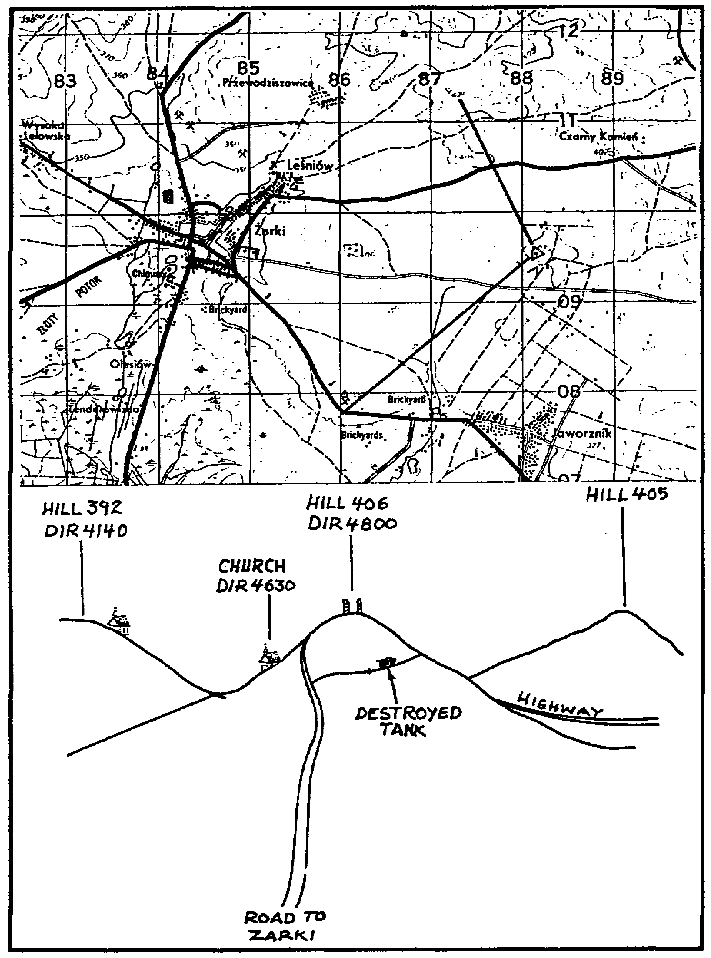

Figure E-1.

E-2

SITUATION: You are the FO, and your supported unit has occupied Hill 407. Your position is indicated on the map (grid square 8809). You have partially completed your terrain sketch and are determining direction to various reference points.

4. You determine the direction to Hill 405 to be--

a. 5800.
b. 5700.
c. 5500.
d. 5400.

5. You have selected the destroyed tank on the trail (grid square 8609) for a registration point. You measure an angular deviation of right 50 mils from Hill 406. What is the direction to the tank?

a. 4,800 mils
b. 4,850 mils
c. 4,900 mils
d. 4,950 mils

6. What grid will you send to the FDC for the registration point?

a. 86550960
b. 865096
c. 86170955
d. 86620925

Use Figure E-2 for questions 7 through 9.

E-3

SITUATION: You are firing a fuze quick registration on registration point one, and the OT factor is two. Rounds four, five, and six are shown on the sketch along with the spottings.

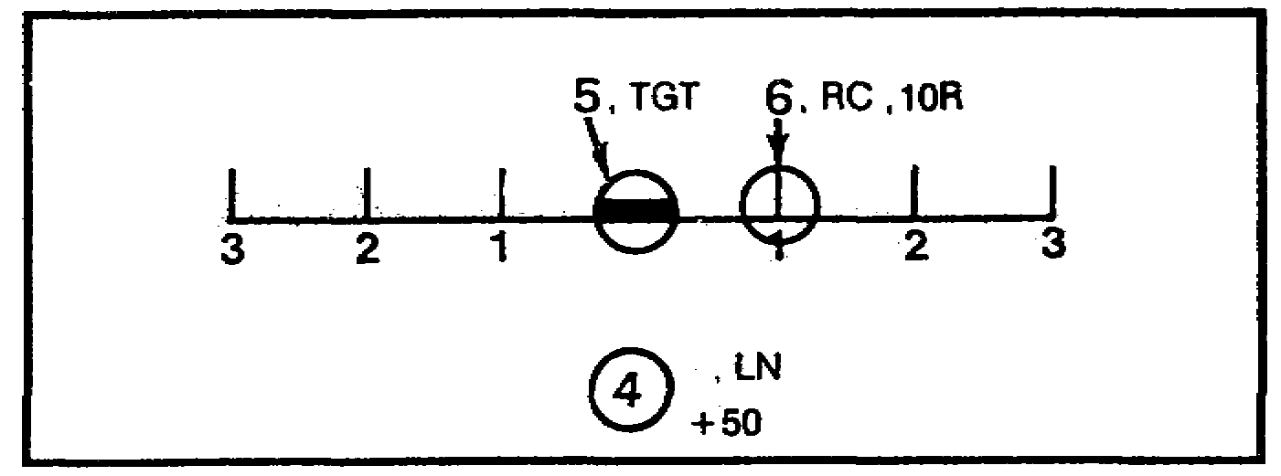

Figure E-2.

7. The mean (average) deviation for rounds five and six is--

a. 10 right.
b. 5 right.
c. 3 right.
d. 20 left.

8. The deviation correction is--

a. left 15.
b. left 10.
c. left 4.
d. right 15.

9. The range correction is--

a. add 25.
b. none.
c. drop 25.
d. drop 50.

SITUATION: You are the FO for the 1st Platoon, Company C, 1-20 Infantry. Battalion FDC has directed you to fire an impact and time registration.

10. Your last correction was add 50. The round impacted beyond the registration point, establishing a 50-meter bracket. What should be your next correction to FDC?

a. repeat
b. one round, drop 25
c. one round, add 25
d. two rounds, drop 25

E-4

11. In Figure E-3, your OT factor is three. What message should you send to the FDC?

a. RECORD AS REGISTRATION POINT 1, TIME REPEAT, OVER.
b. LEFT 20, RECORD AS REGISTRATION POINT 1, TIME REPEAT, OVER.
c. LEFT 20, DROP 10, RECORD AS REGISTRATION POINT 1, TIME REPEAT, OVER.
d. LEFT 10, DROP 20, RECORD AS REGISTRATION POINT 1, TIME REPEAT, OVER.

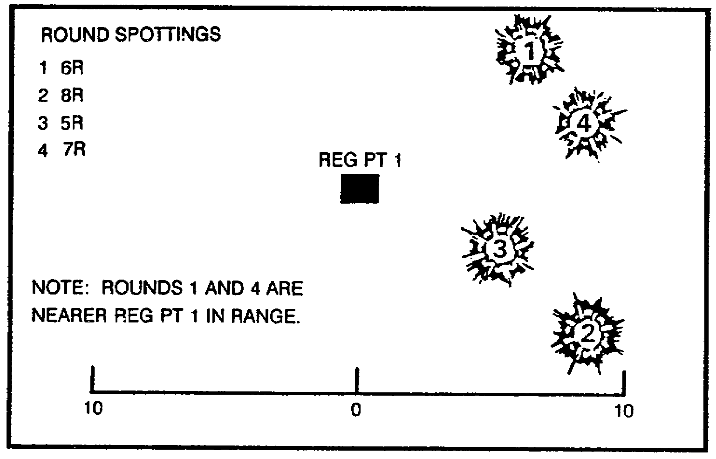

Figure E-3.

12. Your first round was fired in a time registration. The result was graze. What correction should you send to the FDC?

a. up 10
b. up 20
c. up 40
d. up 50

13. What message would you send to the FDC when four rounds are fired using the same data, and the results were three grazes and one air?

a. RECORD AS TIME REGISTRATION POINT 1, END OF MISSION, OVER.
b. UP 10, RECORD AS TIME REGISTRATION POINT 1, END OF MISSION, OVER.
c. UP 10, REGISTRATION POINT 1, END OF MISSION, OVER.
d. UP 20, RECORD AS TIME REGISTRATION POINT 1, END OF MISSION, OVER.

14. If the first round of TIME registration is an air, your next transmission to the FDC is--

a. down 20, repeat, over.
b. three rounds, repeat, over.
c. end of mission, record at time registration, over.
d. two rounds, repeat, over.

E-5

15. The HOB deviation spotting is always measured to the nearest--

a. 1 mil.
b. 5 mils.
c. 10 mils.
d. 20 mils.

16. A spotting of range correct or target is counted as--

a. two overs.
b. two shorts.
c. one over and one short.
d. none of the above.

17. The call for fire in a mortar registration is sent in a maximum of--

a. two parts.
b. three parts.
c. four parts.
d. five parts.

18. The parts of the call for fire are further divided into--.

a. three elements.
b. four elements.
c. five elements.
d. six elements.

19. The three methods of target location are--

a. grid, shift from a known point, and polar plot.
b. grid, polar plot, and cardinal direction.
c. grid, shift from a known point, and eight-place coordinates.
d. grid, eight-place coordinates, and cardinal direction.

20. All grid-located targets for registration must be sent as--

a. twelve-place grids.
b. ten-place grids.
c. eight-place grids.
d. six-place grids.

21. In a polar plot mission, the vertical shift is sent to the nearest--

a. 5 meters.
b. 10 meters.
c. 20 meters.
d. 50 meters.

E-6

22. The OT factor is a value used to convert observer spottings in mils to--

a. corrections in mils.
b. corrections in meters.
c. fit in the binocular.
d. spottings in meters.

23. The OT distance of 3,500 meters is expressed to an OT factor of--

a. 3.
o. 3.5.
c. 4.
d. 3,500.

24. The three types of definite range spottings are--

a. left, right, and line.
b. over, left, and short.
c. over, short, and line.
d. over, short, and range correct.

25. Range corrections for mortars for the refinement data are made to the
nearest- -

a. 10 meters.
b. 25 meters.
c. 50 meters.
d. 100 meters.

26. The three types of deviation spottings are--

a. over, left, and line.
b. over, left, and right.
c. left, right, and line.
d. left, right, and over.

27. Observer spottings are made to the nearest--

a. 1 mil.
b. 3 mils.
c. 5 mils.
d. 10 mils.

28. Deviation corrections of less than ________ meters should not be sent during the adjustment phase of the registration.

a. 10.
b. 20.
c. 50.
d. 100.

E-7

29. If the sheaf is to be adjusted for the mortars, the adjusting points are at the same range or within ____________ meters of the registration point.

a. O.
b. 10.
c. 50.
d. 100.

30. When the sheaf is adjusted, the--

a. mission is ended.
b. mortars are considered safe.
c. map is adjusted.
d. mortars are displaced.

E-8

